Bespoke Options
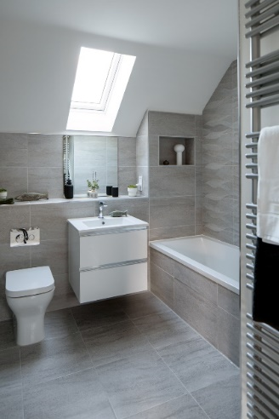
Dalfaber, Aviemore

Kitchen (including Utility rooms) 
Standard range furniture – please choose from one of the eight colour schemes coordinated by the designer. Please see house type drawings for specific layouts/details.
Colour scheme 1
Base and tall units |  | Wall units
Door colour | Easytouch/Front number 966 – Fjord Blue lacquered laminate | Door colour | Easytouch/Front number 966 – Fjord Blue lacquered laminate
Carcase | No. 194 Slate Grey (white internal) | Carcase | No. 194 Slate Grey (white internal)
End panels | No. 212 Fjord Blue  No. 235 Venato Bianco Marble | End panels | No. 212 Fjord Blue
Plinths | No. 212 Fjord Blue
Worktops (laminate) | No. 235 Venato Bianco Marble worktops, upstands and splashbacks with No. 235 Venato Bianco Marble Repro. edges |  |  | Handleless option = Upgrade
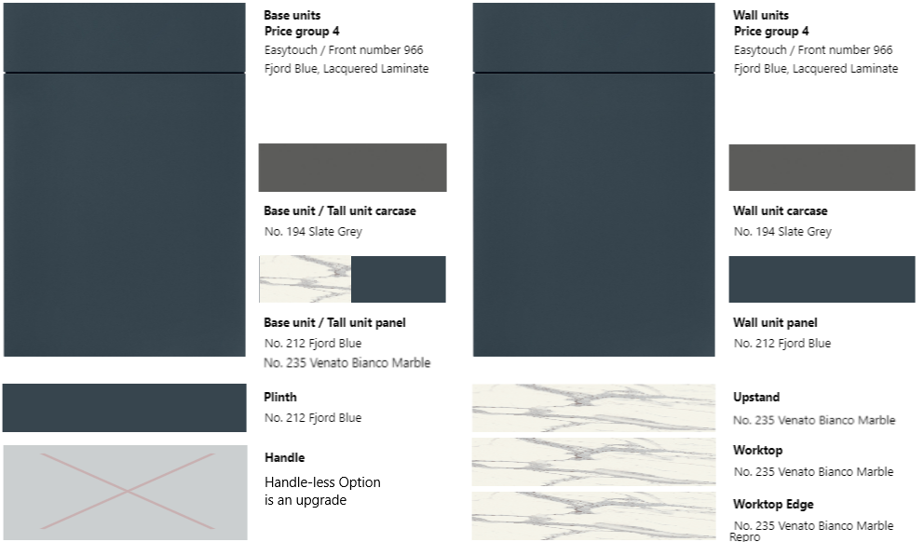
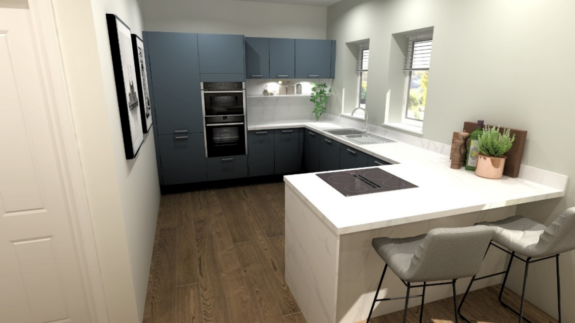

Colour scheme 2
Base and tall units |  | Wall units
Door colour | Laser/Front number 414 – Volcanic Grey | Door colour | Laser/Front number 415 – Sand
Carcase | No. 194 Slate Grey (white internal) | Carcase | No. 122 Sand (white internal)
End panels | No. 207 Volcanic Grey  No. 274 Teramo Marble Repro. | End panels | No. 122 Sand
Plinths | No. 207 Volcanic Grey
Worktops (laminate) | No. 274 Teramo Marble Repro. worktops, upstands, splashbacks and edges |  |  | Handleless option = Standard  (Stainless steel recommended)
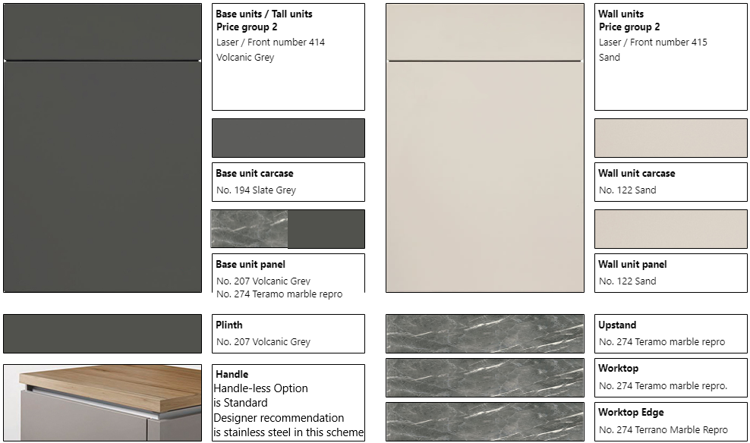
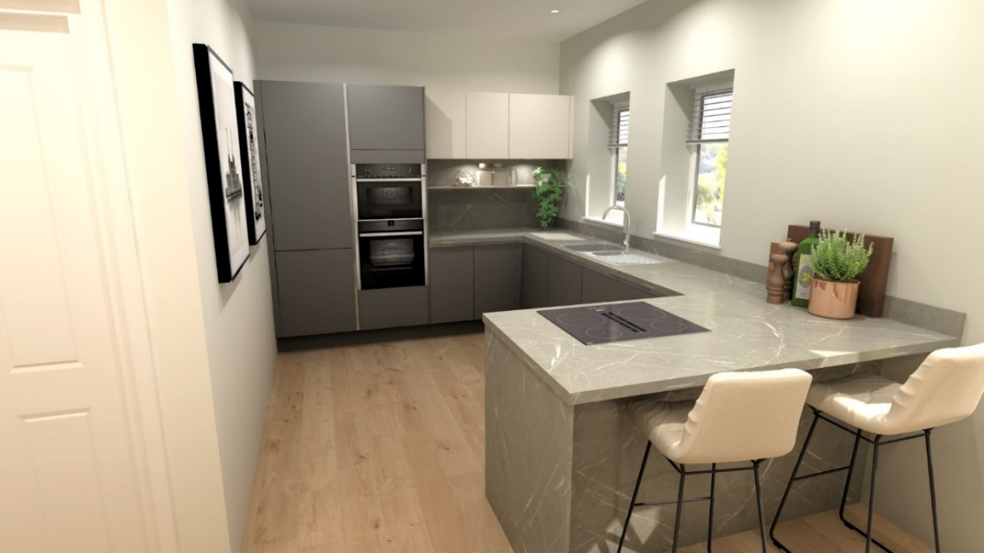

Colour scheme 3
Base and tall units |  | Wall units
Door colour | Laser/Front number 415 – Sand | Door colour | Riva/Front number 843 – Oak Bergamo Repro.
Carcase | No. 122 Sand (white internal) | Carcase | No. 122 Sand (white internal)
End panels | No. 122 Sand  No. 231 Oak Bergamo Repro. | End panels | No. 231 Oak Bergamo Repro.
Plinths | No. 122 Sand
Worktops (laminate) | No. 231 Oak Bergamo Repro. worktops, upstands, splashbacks and edges |  |  | Handleless option = Standard  (Taupe recommended)
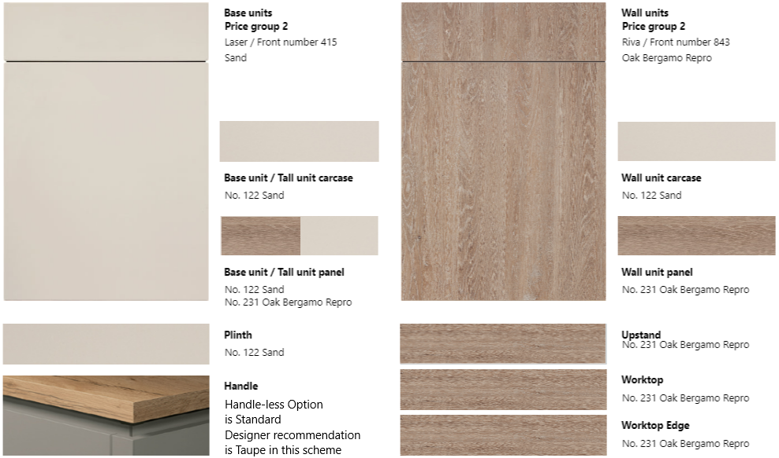
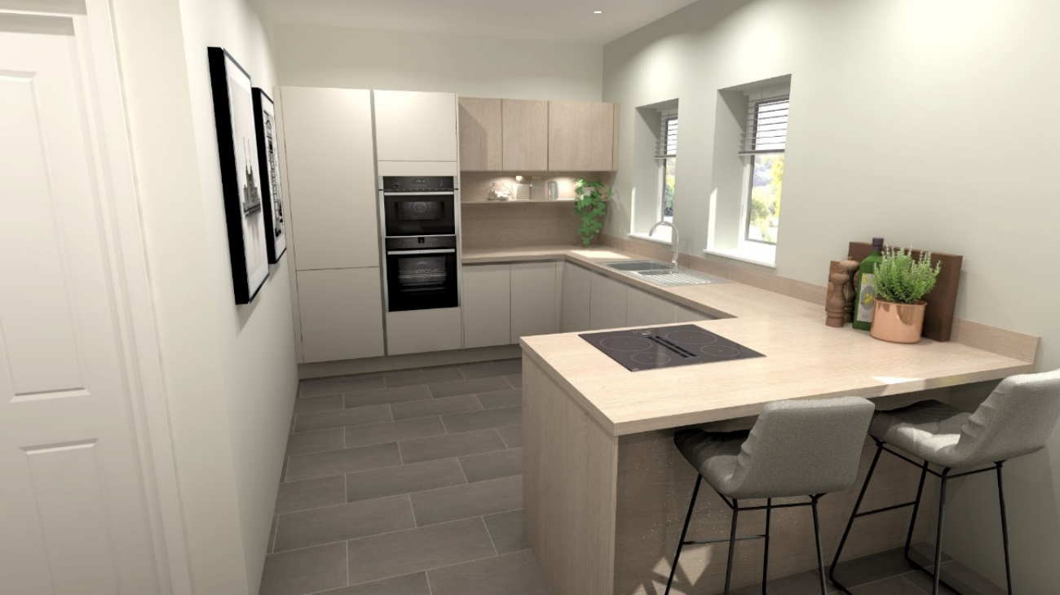

Colour scheme 4
Base and tall units |  | Wall units
Door colour | Riva/Front number 839 Concrete Terra Grey | Door colour | Riva/Front number 842 – Concrete Sand Repro.
Carcase | No. 194 Slate Grey (white internal) | Carcase | No. 122 Sand (white internal)
End panels | No. 149 Concrete Terra Grey  No. 201 Concrete Sand Repro. | End panels | No. 201 Concrete Sand Repro.
Plinths | No. 149 Concrete Terra Grey
Worktops (laminate) | No. 201 Concrete Sand Repro. worktops, upstands, splashbacks and edges |  |  | Handleless option = Standard  (Stainless steel recommended)
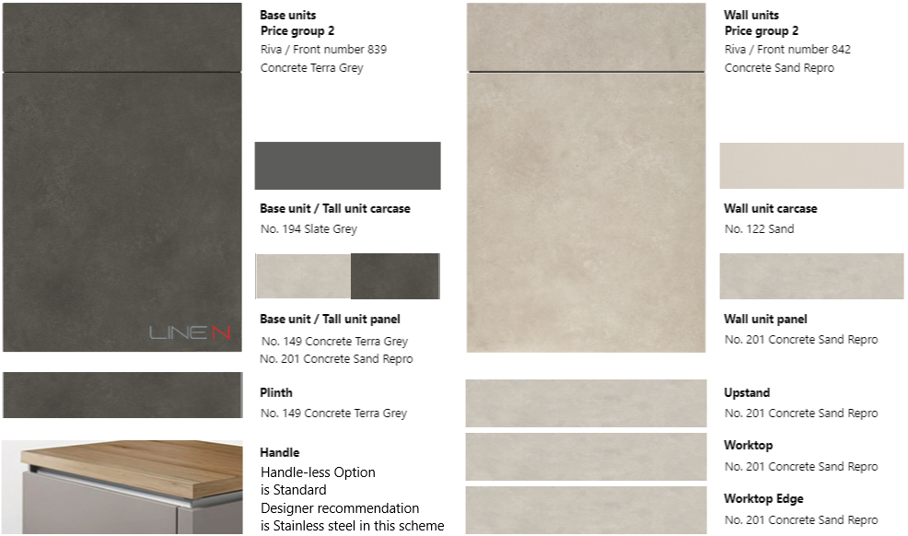
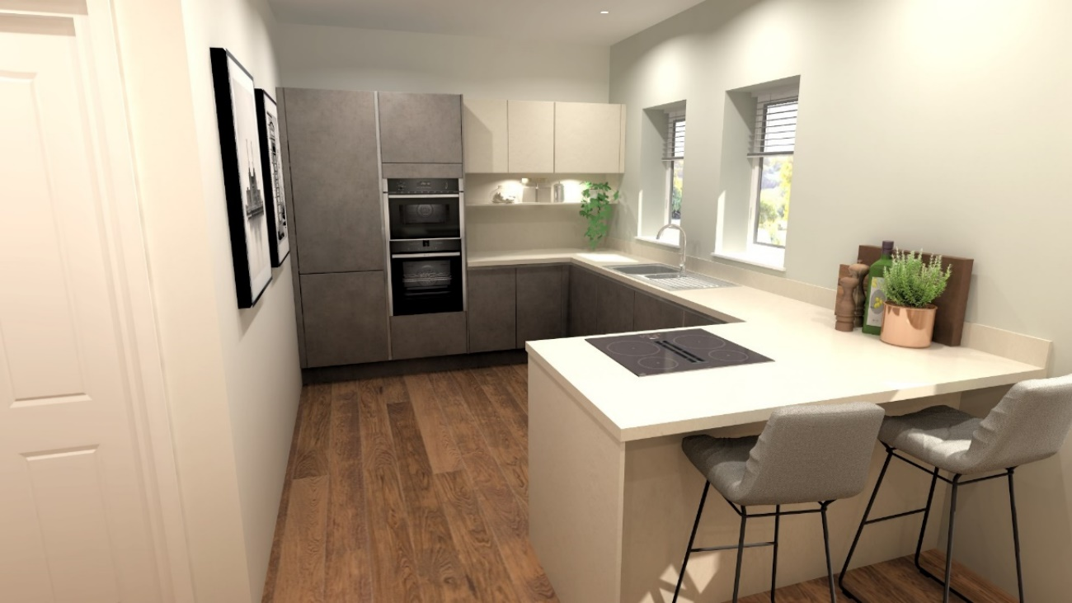

Colour scheme 5
Base and tall units |  | Wall units
Door colour | Easytouch/Front number 964 Mineral Green lacquered laminate | Door colour | Senso/Front number 494 – Lacquer, Premium Honed Jade
Carcase | No. 194 Slate Grey (white internal) | Carcase | No. 089 Stone Grey decor (white internal)
End panels | No. 208 Mineral Green  No. 078 Sanremo Oak Repro. | End panels | No. 494 Lacquer, Honed Jade
Plinths | No. 208 Mineral Green
Worktops (laminate) | No. 078 Sanremo Oak Repro. worktops, upstands, splashbacks and edges |  |  | Handleless option = Upgrade
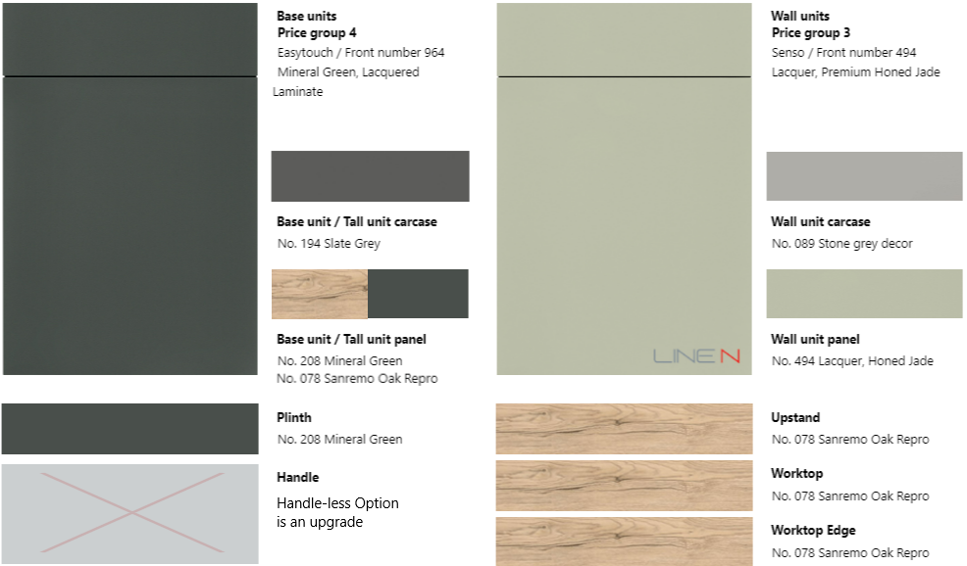
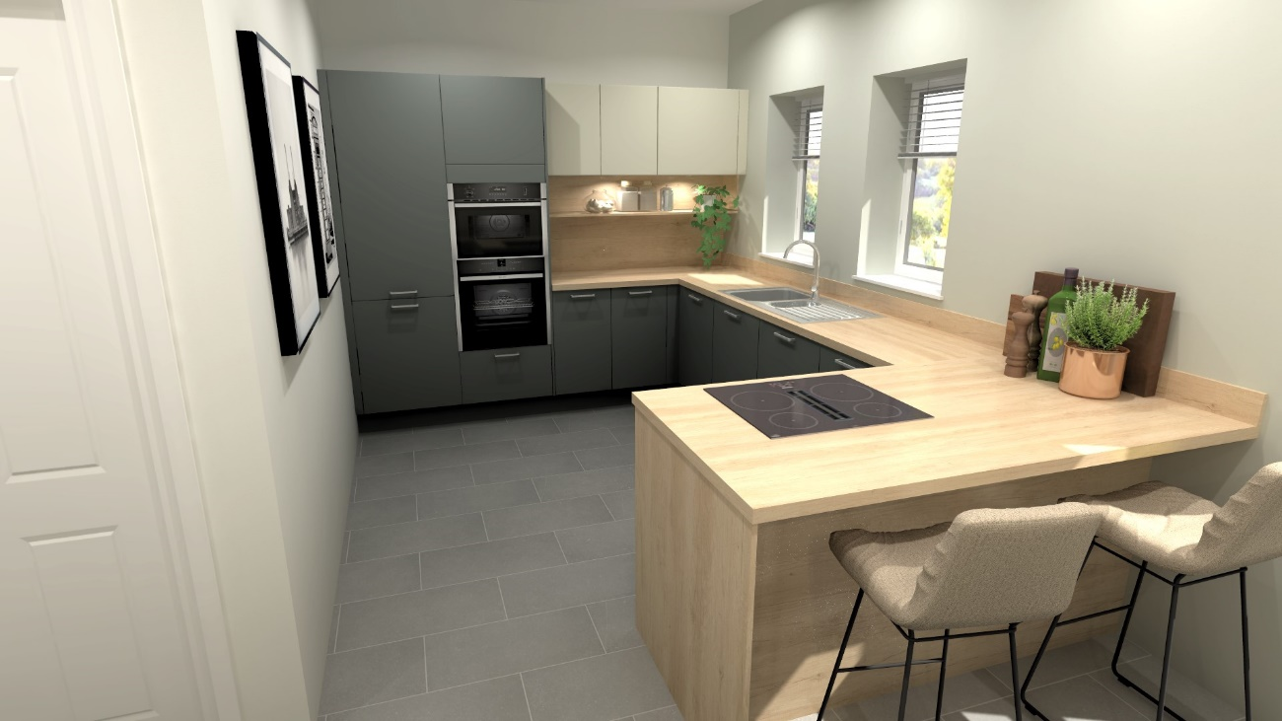

Colour scheme 6
Base and tall units |  | Wall units
Door colour | Laser/Front number 461 Taupe Grey | Door colour | Laser/Front number 417 – Satin Grey
Carcase | No. 071 Taupe Grey (white internal) | Carcase | No. 070 Satin Grey (white internal)
End panels | No. 071 Taupe Grey Ultra Matt lacquered laminate  No. 376 Limestone Repro. | End panels | No. 070 Satin Grey
Plinths | No. 071 Taupe Grey
Worktops (laminate) | No. 376 Limestone Repro. worktops, upstands, splashbacks and edges |  |  | Handleless option = Standard  (Stainless steel recommended)
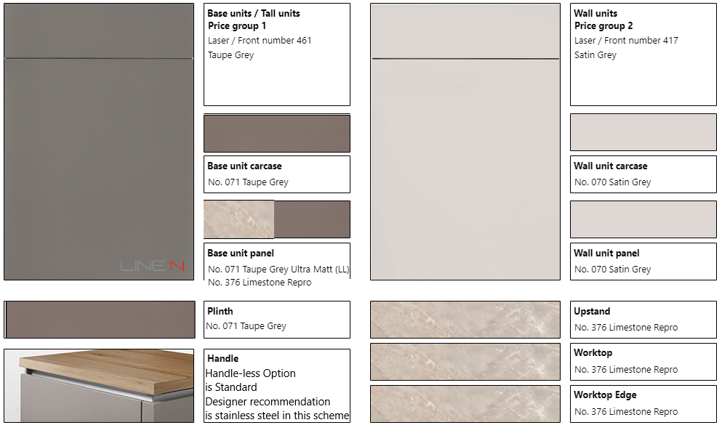
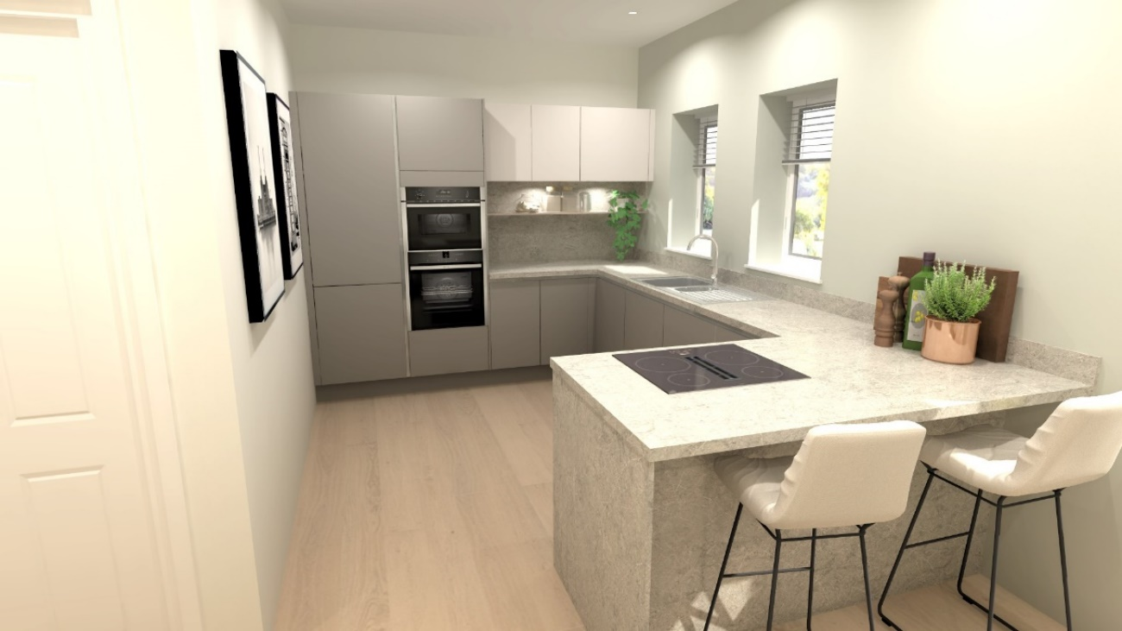

Colour scheme 7
Base and tall units |  | Wall units
Door colour | Laser/Front number 427 Alpine White | Door colour | Structura/Front number 402 – Havana Oak Repro.
Carcase | No. 193 Alpine White (white internal) | Carcase | No. 097 Havana Oak Repro. (white internal)
End panels | No. 193 Alpine White  No. 097 Havana Oak Repro. | End panels | No. 097 Havana Oak Repro.
Plinths | No. 193 Alpine White
Worktops (laminate) | No. 097 Havana Oak Repro. worktops, upstands, splashbacks and edges |  |  | Handleless option = Standard  (Black recommended)
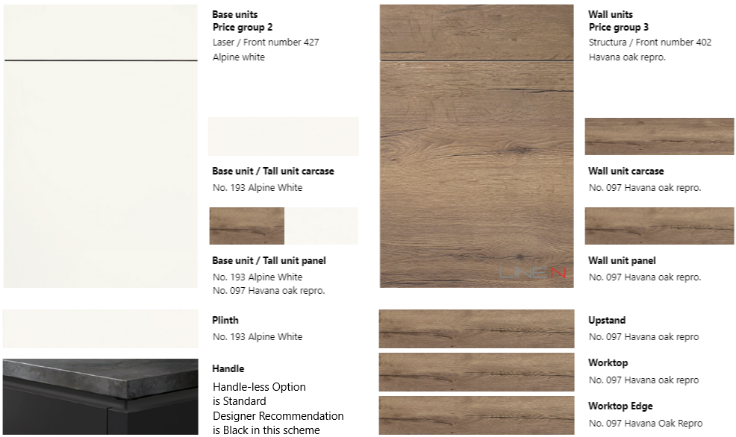
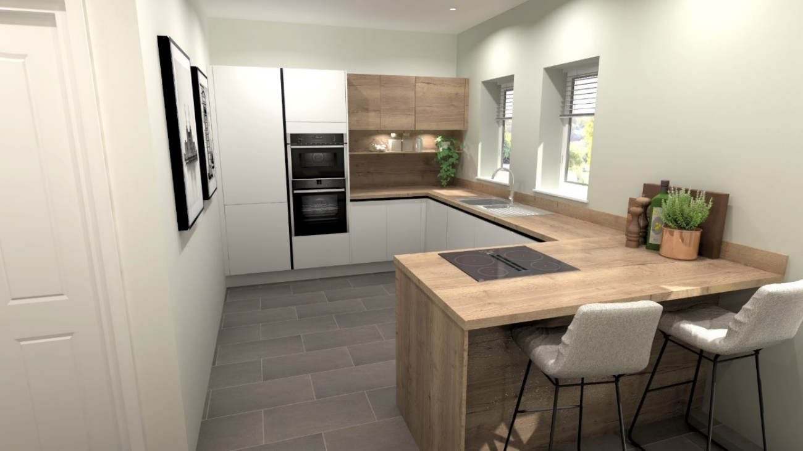

Colour scheme 8
Base and tall units |  | Wall units
Door colour | Senso/Front number 492 Lacquer, Premium Honed Coral | Door colour | Touch/Front number 338 – Lacquered laminate Satin Grey Supermatt
Carcase | No. 070 Satin Grey (white internal) | Carcase | No. 070 Satin Grey (white internal)
End panels | No. 492 Lacquer, Honed Coral  No. 322 White Terrazo Repro. | End panels | No. 070 Satin Grey
Plinths | No. 217 Coral
Worktops (laminate) | No. 322 White Terrazo Repro. worktops, upstands, splashbacks and edges |  |  | Handleless option = Upgrade
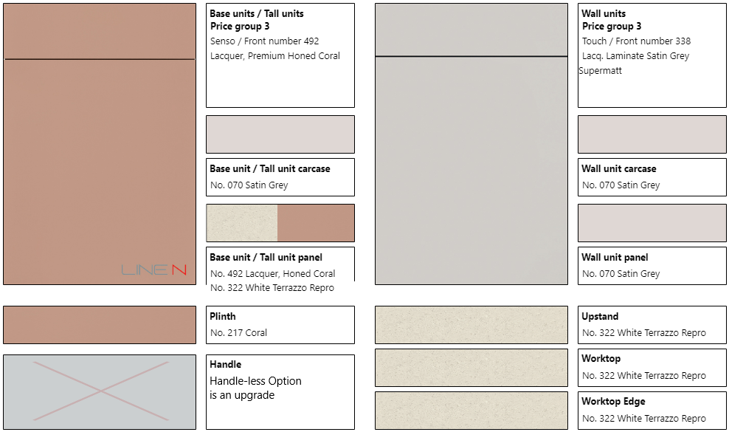
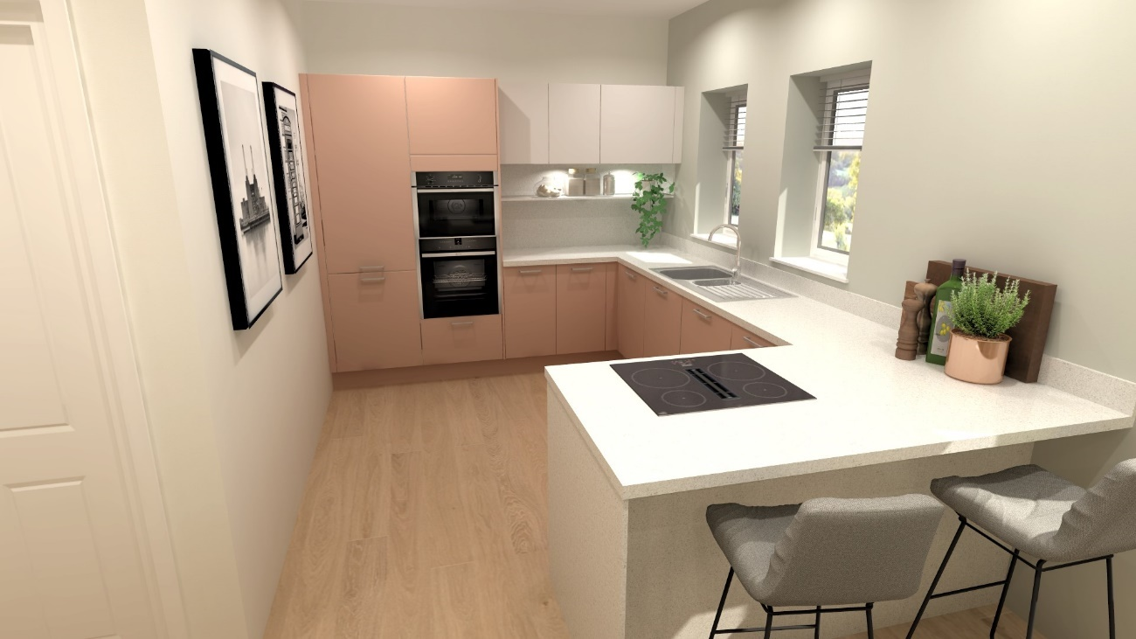

Sensio Apex TrioTone under-unit lighting will be fitted as shown on house type/plot specific drawings.
The colour schemes shown above match the physical sample boards available for viewing within the Marketing Suite and have been designer coordinated to provide varying options. Door colour choices are generally interchangeable on request.
They require a choice of handle (or handleless rail which may be available at no extra cost or chargeable depending on colour scheme chosen) from those shown below and via samples.
Standard range handles
192 Metal handle, Brilliant chrome | 222 Metal handle, Gold coloured | 228 Metal handle, Bronze colour | 251 Metal handle, Black | 276 Metal handle, Antique iron colour, Matt
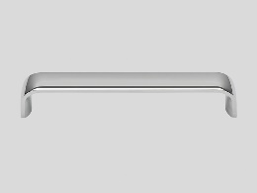 | 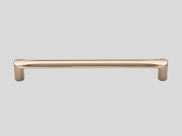 | 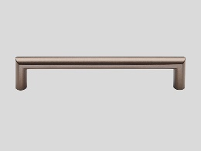 | 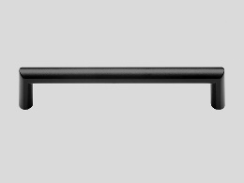 | 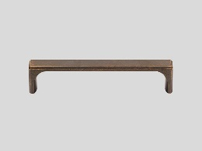
284 Metal handle, Antique silver colour, Matt | 408 Metal handle, Stainless steel finish | 498 Metal handle, Brilliant chrome | 502 Metal handle, Black | 608 Metal handle, Stainless steel finish, Matt
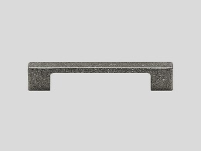 | 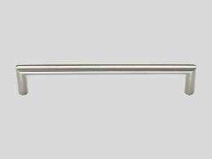 | 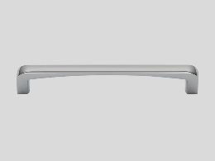 | 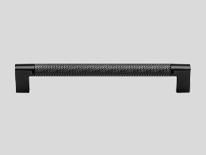 | 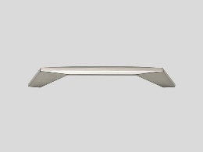
610 Cast iron knob, Black | 715 Metal handle, Brushed anthracite
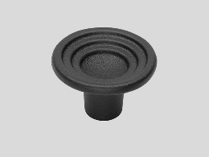 | 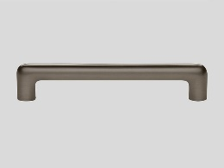
Upgrade range handles (available at additional cost
019 Metal handle, Stainless steel finish, Matt | 223 Bow handle, Gold coloured | 229 Wooden handle, Walnut | 250 Bow handle, Black | 745 Wooden handle, Oak
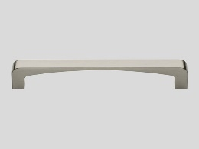 | 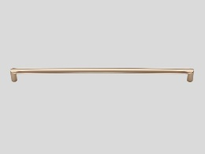 | 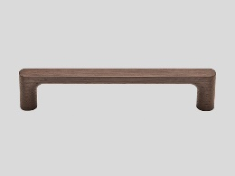 | 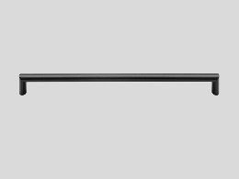 | 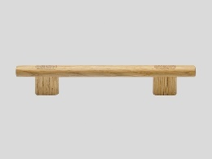
Handleless rails (may incur additional cost on some furniture choices)
016 Alpine White | 004 White | 027 Black | 025 Taupe Grey | 006 Satin Grey
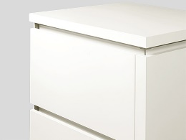 | 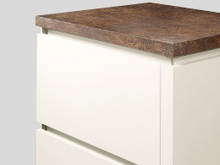 | 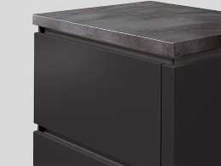 | 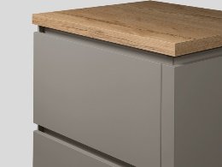 | 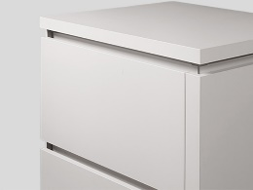
009 Stone Grey | 011 Slate Grey | 007 Sand | 002 Stainless steel | 024 Yellow gold
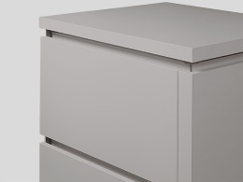 | 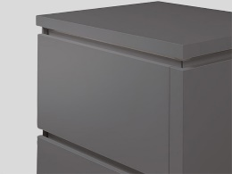 | 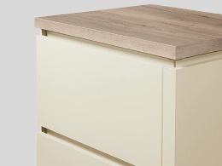 | 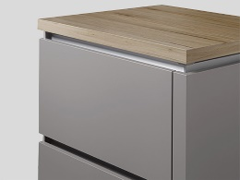 | 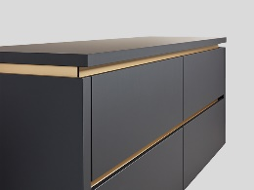
Upgrade Shaker doors (items shown here can be requested via the Customer Upgrades document and will be individually priced)
White  Cascada 774 | Stone Grey  Cascada 772 | Reed Green  Cascada 776 | Fjord Blue  Cascada 778
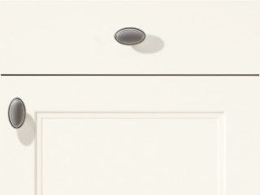 | 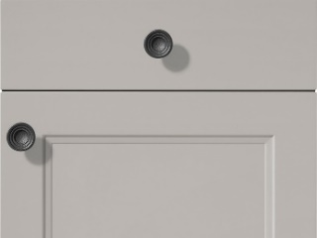 | 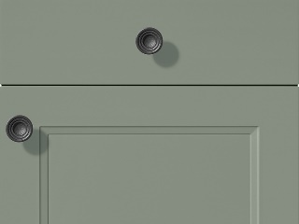 | 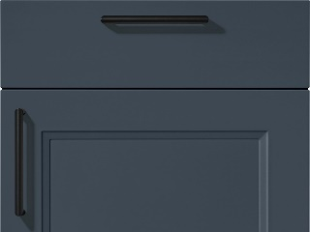
An upgrade can be provided from the standard synthetic cutlery tray to a beech wood version
Standard synthetic | Upgrade beech wood
Upgrade Diore Quartz 20mm worktops (items shown here can be requested via the Customer Upgrades document and will be individually priced – standard for the Kitchen in HT193/212/230).
These will also require upgrade to under-mounted sinks, which can also be specified in the alternate colour finishes detailed under “Sinks and taps”.
Modenese | Galactic | Rydal | Alba | Barollo
 |  |  |  | 
Provence | Ajaccio | Calacatta Vagli | Sancerre | Lapis Grey
 | 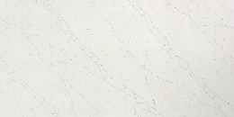 | 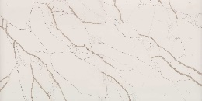 | 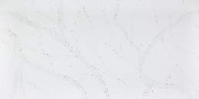 | 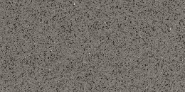

Upgrade niche cladding/décor with digitally printed motifs in lieu of splashback/s may be available on request/at additional cost and include colours/patterns such as the below.
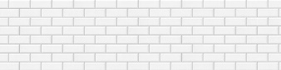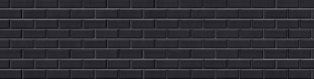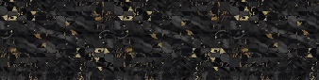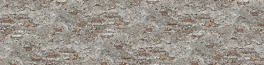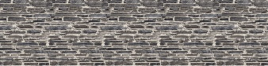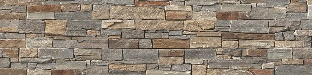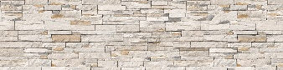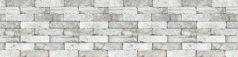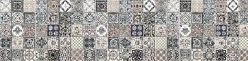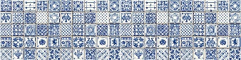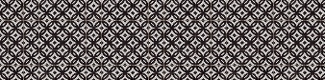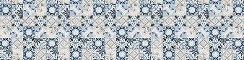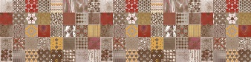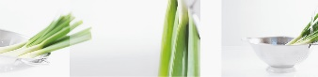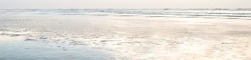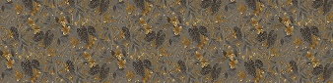

On screen and printed colours may vary slightly from the actual product, please refer to physical samples for colour matching.
Worktops, upstands and splashbacks are supplied in maximum lengths depending on the range chosen, which may result in joints, some of which may be conspicuous due to adjacent angles and the variation of pattern and colour within each finsh.

Sinks and taps
Kitchen: |  | Blanco Dinas 6S inset stainless steel sink and Mida chrome tap
Utility Room: |  | Blanco Tipo 45S inset stainless steel sink and Daras chrome tap
The above items are standard specification, with upgrades to Blanco Silgranit Sona 6 S sinks and Mida taps available in a choice of 6 colours for the Kitchen:
Volcano Grey | Black |  | White | Anthracite | Soft White | Coffee
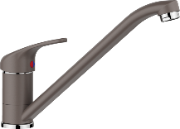 | 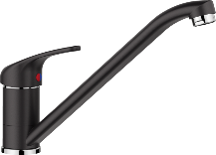 |  | 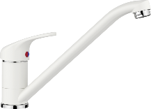 | 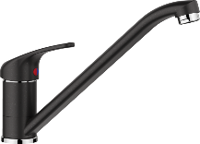 | 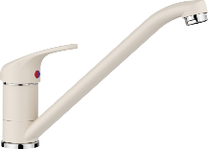 | 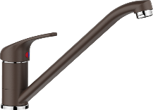
In addition, an upgrade to a Quooker Fusion Square boiling water tap is availlable in a choice of 6 colours:
3FSCHR Chrome | 3FSRVS Stainless Steel |  | 3FSBLK Black | 3FSPTN Patinated Brass | 3FSGLS Gold | 3FSGME Gun Metal

Appliances
Fitted as standard are an integrated stainless steel electric oven and separate combination microwave oven, electric induction hob, recirculating extractor hood (function built-in to the hob in some cases), integrated dishwasher and an integrated larder refrigerator, or in some cases, separate integrated larder fridge and freezer. Please see kitchen layouts for house type specific details.
- | Neff B4ACF1AN0B single oven
- | Neff C1AMG84N0B combination microwave/oven
- | Neff T66FHE4L0 60cm induction hob and D55MH56N0B 60cm canopy hood  or Neff V56NBS1L0 60cm vented induction hob  or Neff V58NBS1L0 80cm vented induction hob
- | Indesit IB7030A1D1 70/30 split integrated fridge/freezer  or Hotpoint HS1801AA larder fridge and Hotpoint HF1801EFAA larder freezer
- | Indesit D2IHD526 integrated dishwasher

Wall and floor tiling

A choice of twelve pre-selected coordinating selections will be available (these are fixed and cannot be inter-selected). Where required, the trim will be 12.5mm chrome finish.
Selection | Wall tiling  (generally half-height) | Feature wall tiling  (see room layouts) | Floor tiling | Grout
A | Image Silver 33.3x59.2cm  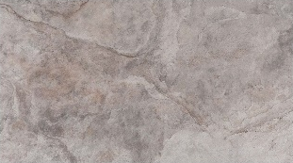 | N/A | Image Silver  44.3x44.3cm  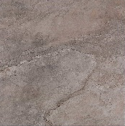 | Manhattan
B | Nantes Acero 33.3x59.2cm  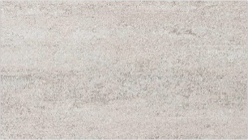 | Mosaico Nantes Acero 33.3x59.2cm  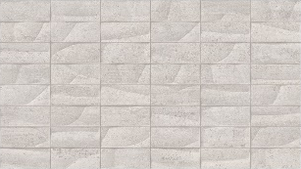 | Nantes Acero  44.3x44.3cm  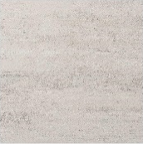 | Gris
C | Rodano Acero 33.3x59.2cm   | N/A | Rodano Acero  44.3x44.3cm  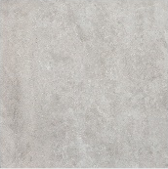 | Manhattan
D | Bottega White 33.3x59.2cm   | Spiga Bottega White  33.3x59.2cm  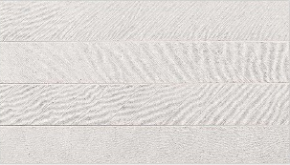 | Bottega White  44.3x44.3cm  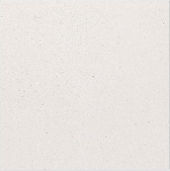 | Blanco (Wall Tiling)  Gris (Floor Tiling)
F | Madagascar Natural  33.3x59.2cm  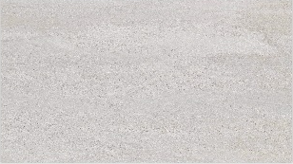 | Ona Natural  33.9x59.2cm  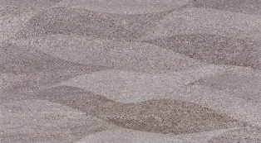 | Madagascar Natural  44.3x44.3cm  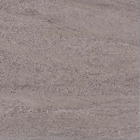 | Manhattan
G | Nantes Caliza  33.3x59.2cm  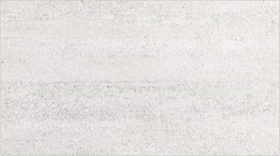 | Mosaico Nantes Caliza 33.3x59.2cm  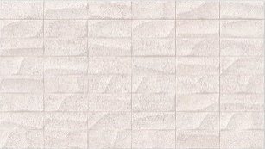 | Nantes Caliza  44.3x44.3cm  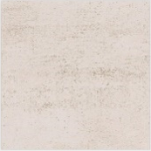 | Nacare
H | Mystic Beige  33.3x59.2cm  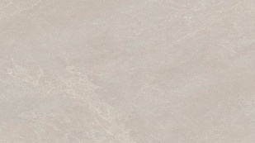 | Spiga Mystic Beige 33.3x59.2cm  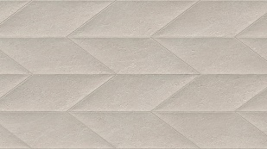 | Mystic Beige  44.3x44.3cm  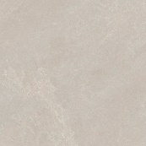 | Gris
I | Mystic Grey  33.3x59.2cm  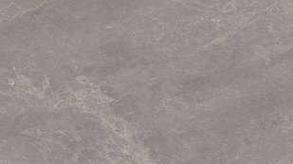 | Spiga Mystic Grey 33.3x59.2cm  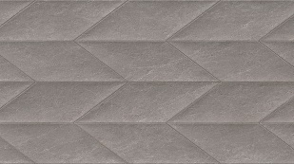 | Mystic Grey  44.3x44.3cm  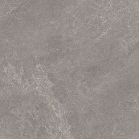 | Cemento
J | Coral Acero  33.3x59.2cm   | Deco Coral Acero 33.3x59.2cm   | Coral Acero  44.3x44.3cm   | Gris
K | Coral Caliza  33.3x59.2cm   | Deco Coral Caliza 33.3x59.2cm   | Coral Caliza  44.3x44.3cm   | Gris
L | Coral Topo  33.3x59.2cm   | Deco Coral Topo 33.3x59.2cm   | Coral Topo  44.3x44.3cm   | Gris

Your choice of tiling for each “wet” room should therefore be made from A-L as above, noting that some rooms may not have a feature wall (see room layouts).

Sanitary ware and fitments
Sanitary ware colour (unless specified otherwise below) will be – White. An upgrade to black finish brassware is available at additional charge. Please see house type drawings for specific layouts/details.
Ground floor Cloakroom/Shower room (where applicable) | Urban C 45cm wall hung basin with chrome bottle trap.
Ground floor Cloakroom/Shower room (where applicable) | Curve basin mixer with slotted clicker waste.
Ground floor Cloakroom/Shower room (where applicable) | Urban C close-coupled WC with soft close seat.
Ground floor Cloakroom/Shower room (where applicable) | JT Fusion 120x76cm low profile shower tray (where applicable).
Ground floor Cloakroom/Shower room (where applicable) | Inter 1 90cm fixed shower screen (where applicable).
Ground floor Cloakroom/Shower room (where applicable) | Smart thermostatic shower column.
Bathroom | Alma 170 x 70cm tiled in bathtub with Exafill system
Bathroom | Inter 2b 80cm bath/shower pivot screen (where applicable)
Bathroom | Hotels single lever bath filler, concealed thermostatic valve.
Bathroom | Smart thermostatic shower column (where applicable).
Bathroom | JT Fusion 90x90cm or 170x80cm or 120x76cm low-profile shower tray with Inter 8 90cm bi-fold or Inter 9 120cm sliding or Inter 1 80cm fixed shower screen (where applicable)
Bathroom | Round extra flat 20cm rain shower head with arm, Minimal hand shower, outlet/bracket and hose andd Round 2 way concealed thermostatic valve (where applicable)
Bathroom | Urban C back-to-wall WC with soft close seat, Rondo flush button and Smart Line concealed cistern with frame.
Bathroom | Marne 59.5x47.7x39cm wall-hung vanity unit, finish choices shown below, with white worktop and Slender countertop basin.
Bathroom | Curve high spout basin mixer with slotted clicker waste.
En suite/s | JT Fusion 90x90cm or 100x75cm or 120x76cm or 140x70cm or 170x80cm low profile shower tray.
En suite/s | Inter 9 100cm or 120cm sliding shower screen/door or Inter 1 80cm or 90cm fixed shower screen or Inter 8 90cm bi-fold shower screen.
En suite/s | Round extra flat 20cm rain shower head with arm, Minimal hand shower, outlet/bracket and hose and Round 2 way concealed thermostatic valve.
En suite/s | Alma 170 x 70cm tiled in bathtub with Exafill system. (where applicable)
En suite/s | Hotels single lever bath filler, concealed thermostatic valve. (where applicable)
En suite/s | Urban C back-to-wall WC with soft close seat, Rondo flush button and Smart Line or Smart Line low-level concealed cistern with frame.
En suite/s | Marne 59.5x47.7x39cm wall-hung vanity unit, finish choices shown below, with white worktop and Slender countertop basin.
En suite/s | Curve high spout basin mixer with slotted clicker waste.
The Marne vanity unit is available in any of the 4 below colours, please specify.
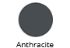 |  | 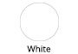 | 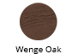 | 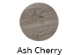
The heated towel rail will be a Towelrads Pisa Plus pearl shine silver or anthracite finish (please check plot number for confirmation) model in lieu of a radiator. This rail can either be heated from the central heating system or switched to electric operation when the house does not require central heating.
Please consult the sales adviser for further information. Not all items/details will be applicable to every situation, please review plot specific drawings when considering these options.
Although every care and attention has been taken to ensure the accuracy of all information given, the contents do not form part of or constitute a representation or warranty of any contract.
Scotia Homes Limited reserves the right to vary the above specifications (including any quoted sizes and specific products/model nos.) where necessary but to similar or higher standards.

