Bespoke Options
Dalfaber, Aviemore
(Plots 038-039, 041-044 & 065-071)

Kitchen (including Utility rooms) 
Standard range furniture – please choose from one of the door frontal and carcase colour choices below. Please see house type drawings for specific layouts/details.
Door colour |  | Carcase detail
Laser 427 Alpine White |  | White internal carcase, 193 Alpine White external carcase including plinths, with any décor panels in Alpine White. Wrap-around panels to the end of peninsular and base unit runs will be in the same material chosen for the worktops.
Laser 417 Satin Grey |  | White internal carcase, 070 Satin Grey external carcase including plinths, with any décor panels in Satin Grey. Wrap-around panels to the end of peninsular and base unit runs will be in the same material chosen for the worktops.
Laser 415 Sand |  | White internal carcase, 122 Sand external carcase including plinths, with any décor panels in Sand. Wrap-around panels to the end of peninsular and base unit runs will be in the same material chosen for the worktops.
Laser 461 Taupe Grey |  | White internal carcase, 071 Taupe Grey external carcase including plinths, with any décor panels in Taupe Grey. Wrap-around panels to the end of peninsular and base unit runs will be in the same material chosen for the worktops.
Laser 414 Volcanic Grey |  | White internal carcase, 127 Black external carcase including plinths, with any décor panels in Volcanic Grey. Wrap-around panels to the end of peninsular and base unit runs will be in the same material chosen for the worktops.
Laser 463 Black Concrete |  | White internal carcase, 127 Black external carcase including plinths, with any décor panels in Black Concrete. Wrap-around panels to the end of peninsular and base unit runs will be in the same material chosen for the worktops.
Riva 892 Concrete Grey |  | White internal carcase, 070 Satin Grey external carcase including plinths, with any décor panels in Concrete Grey. Wrap-around panels to the end of peninsular and base unit runs will be in the same material chosen for the worktops.
Riva 889 Concrete Slate Grey |  | White internal carcase, 194 Slate Grey external carcase including plinths, with any décor panels in Concrete Slate Grey. Wrap-around panels to the end of peninsular and base unit runs will be in the same material chosen for the worktops.
Riva 843 Oak Bergamo |  | White internal carcase, 071 Taupe Grey external carcase including plinths, with any décor panels in Oak Bergamo. Wrap-around panels to the end of peninsular and base unit runs will be in the same material chosen for the worktops.
Riva 893 Sanremo Oak |  | White internal carcase, 078 Sanremo Oak external carcase including plinths, with any décor panels in Sanremo Oak. Wrap-around panels to the end of peninsular and base unit runs will be in the same material chosen for the worktops.

Standard range worktops – please choose from one of the laminate colour choices below. This will include upstands and splashback/s as shown on house type drawings.
378 Black Concrete | 330 Concrete Grey | 354 Concrete Slate Grey
350 Flamed Finish Bronze | 078 Sanremo Oak | 324 Carrara Bronze Marble
235 Venato Bianco Marble | 322 White Terrazo | 220 Arizona Pine
231 Bergamo Oak | 376 Limestone | 361 Caspian Grey Marble
Standard range handles – please choose from one of the colour choices below.
612 | 708 Metal handle, stainless steel finish | 221 Metal handle, stainless steel finish | 069 Metal handle, stainless steel finish
251 Metal handle, black | 408 Metal handle, stainless steel finish | 222 Metal handle, gold coloured | 233 Metal handle, gold coloured
228 Bow handle, bronze coloured | 098 Metal handle, matt nickel | 242 Metal knob, black | 241 Metal knob, stainless steel finish
244 Metal knob, black | 246 Metal knob, bronze metallic colour

Upgrade range furniture – please choose from one of the door frontal and carcase colour choices below. Please see house type drawings for specific layouts/details.
Door colour |  | Carcase detail
Structura (PG4) 406 Como Oak |  | White internal carcase, 122 Sand external carcase including plinths, with any décor panels in Como Oak. Wrap-around panels to the end of peninsular and base unit runs will be in the same material chosen for the worktops.
Structura (PG4) 407 Milano Walnut |  | White internal carcase, 127 Black external carcase including plinths, with any décor panels in Milano Walnut. Wrap-around panels to the end of peninsular and base unit runs will be in the same material chosen for the worktops.
Flash (PG4) 455 Satin Grey High Gloss |  | White internal carcase, 070 Satin Grey external carcase including plinths, with any décor panels in Satin Grey. Wrap-around panels to the end of peninsular and base unit runs will be in the same material chosen for the worktops.
Senso (PG4) 494 Jade |  | White internal carcase, 193 Alpine White external carcase including plinths, with any décor panels in Jade. Wrap-around panels to the end of peninsular and base unit runs will be in the same material chosen for the worktops.
Senso (PG4) 495 Olive Green |  | White internal carcase, 194 Slate Grey external carcase including plinths, with any décor panels in Olive Green. Wrap-around panels to the end of peninsular and base unit runs will be in the same material chosen for the worktops.
Easytouch (PG4) 966 Fjord Blue |  | White internal carcase, 194 Slate Grey external carcase including plinths, with any décor panels in Fjord Blue. Wrap-around panels to the end of peninsular and base unit runs will be in the same material chosen for the worktops.
Cascada (PG7) 776 Reed Green |  | White internal carcase, 089 Stone Grey external carcase including plinths, with any décor panels in Reed Green. Wrap-around panels to the end of peninsular and base unit runs will be in the same material chosen for the worktops.
Cascada (PG7) 778 Fjord Blue | 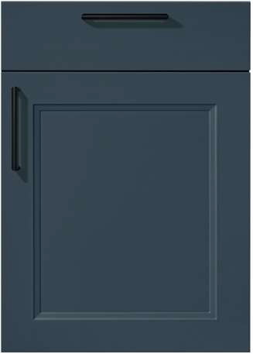 | White internal carcase, 194 Slate Grey external carcase including plinths, with any décor panels in Fjord Blue. Wrap-around panels to the end of peninsular and base unit runs will be in the same material chosen for the worktops.
Nordic (PG7) 788 Sand |  | White internal carcase, 122 Sand external carcase including plinths, with any décor panels in Sand. Wrap-around panels to the end of peninsular and base unit runs will be in the same material chosen for the worktops.
Nordic (PG7) 786 Slate Grey |  | White internal carcase, 194 Slate Grey external carcase including plinths, with any décor panels in Slate Grey. Wrap-around panels to the end of peninsular and base unit runs will be in the same material chosen for the worktops.

Upgrade range worktops – please choose from one of the 20mm quartz colour choices below. This will include upstands and splashback/s as shown on house type drawings.
These will also require upgrade to under-mounted sinks, which can also be specified in the alternate colour finishes detailed under “Sinks and taps”.
Diore Arezzo | Diore Tromso | Diore Sancerre | Diore Rydal | Diore Ariel
Diore Calvi | Diore Gable | Diore Galactic | Diore Icarus | Diore Ultra Etienne
Upgrade range handles – please choose from one of the colour choices below.
019 Metal handle, stainless steel finish | 229 Wooden handle, walnut | 745 Wooden handle, oak | 223 Bow handle, gold coloured
250 Metal handle, black
Upgrade channel handles – please choose from one of the colour choices below. This option is not available for the Cascada and Nordic shaker ranges
No. 002 Stainless steel finish | No. 016 Alpine white | No. 006 Satin Grey
No. 007 Sand | No. 011 Slate Grey | No. 012 Bronze Metal Coloured
No. 024 Yellow Gold Coloured | No. 025 Taupe Grey | No. 027 Black

Sensio Hype TrioTone under-unit lighting will be fitted as shown on house type/plot specific drawings.
An upgrade can be provided from the standard synthetic cutlery tray to a beech wood version
Standard synthetic | Upgrade beech wood
On screen and printed colours may vary slightly from the actual product, please refer to physical samples for colour matching.
Worktops, upstands and splashbacks are supplied in maximum lengths depending on the range chosen, which may result in joints, some of which may be conspicuous due to adjacent angles and the variation of pattern and colour within each finish.

Sinks and taps
Kitchen: |  | Blanco Dinas 6S inset stainless steel sink and Mida chrome tap
Utility Room: |  | Blanco Tipo 45S inset stainless steel sink and Daras chrome tap
The above items are standard specification, with upgrades to Blanco Silgranit Sona 6 S sinks and Mida taps available in a choice of 6 colours for the Kitchen:
Volcano Grey | Black |  | White | Anthracite | Soft White | Coffee
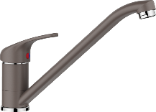 | 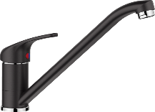 |  | 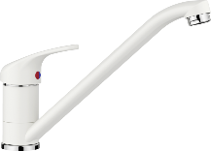 | 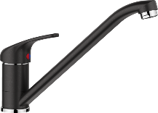 | 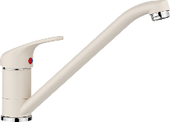 | 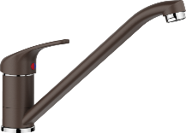

In addition, an upgrade to a Quooker Fusion Square boiling water tap is availlable in a choice of 6 colours:
FNSCHR Chrome | FNSSST Stainless Steel | FNSBLK Black | FNSGME Gun Metal | 3FSRCO Rose Copper | FNSPTB Patinated Brass
 |  |  |  | 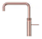
FNSGLD Gold

Appliances


Fitted as standard are an integrated stainless steel electric oven (a second combination microwave oven will be fitted in the Somerville and Telford house types), electric induction hob, recirculating extractor hood (function built-in to the hob in some cases), integrated dishwasher and a tall integrated fridge/freezer. Please see kitchen layouts for house type specific details.

- | Smeg SF6100VB3 - single black fan oven
- | Smeg SI2641D 60cm induction hob or SI2741D 75cm or HOBD472D 70cm venting induction hob, depending on layout
- | Smeg KI52E3 52cm or KSG73E 73cm canopy recirculation extractor hood, depending on layout
- | Smeg DI262D 60cm dishwasher
- | Smeg UKC81721E 70/30 tall fridge/freezer

Bathroom (including En Suite shower room/s)
Whilst the choice of wall tiling is entirely your own, we recommend that you consider the size of individual tiles when considering locations, as this may have an effect on both the visual appearance, and also the need for ‘cut’ tiles upon installation.
Where orientation is not specifically confirmed on your colour choice requests, these will be fitted ‘portrait’ to bathrooms/en suites, where applicable. This may have an effect on the visual appearance, as noted above.
N.B. Whilst all floor (available as an upgrade through your Extras) tiles listed are suitable for general internal floor use, further advice must be sought with regard to slip ratings if these are to be installed in a ‘wet’ floor environment.

Standard range wall tiling
Range/Colour |  | Tile size | Trim (not in Utility rooms / cupboards) | Grout/Sealant | Upgrade Floor Tile (recommended)
Indic | 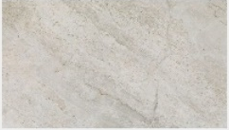 | 250x443mm | 10 mm White | Gris (grey) | Indic (443x443mm)  Grout = Gris | 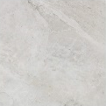
Butan Bone | 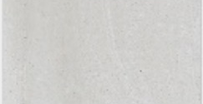 | 250x443mm | 10 mm White | Gris (grey) | Butan Bone  (443x443mm)  Grout = Gris | 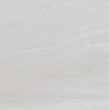
Shine Dark | 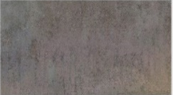 | 250x443mm | 10 mm White | Antracita | Ferroker  (443x443mm)  Grout = Antracita | 
Bottega Caliza | 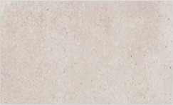 | 250x443mm | 10 mm White | Caliza   | Bottega Caliza  (443x443mm)  Grout = Gris | 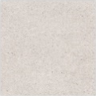
Bottega Acero | 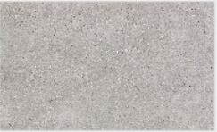 | 250x443mm | 10 mm White | Manhattan (mid grey) | Bottega Acero  (443x443mm)  Grout = Manhattan | 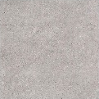
Image White |  | 250x443mm | 10 mm White | Blanco (white) | Image White (443x443mm)  Grout = Gris | 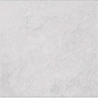
Image Silver | 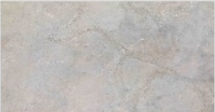 | 250x443mm | 10 mm White | Manhattan (mid grey) | Image Silver (443x443mm)  Grout = Maanhattan | 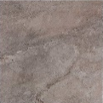
Madagascar Blanco |  | 250x443mm | 10 mm White | Blanco (white) | Madagascar Blanco  (443x443mm)  Grout = Gris | 
Madagascar Natural |  | 250x443mm | 10 mm White | Gris (grey) | Madagascar Natural  (443x443mm)  Grout = Gris | 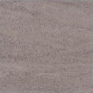
Ona Blanco | 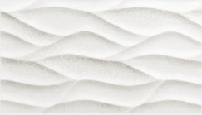 | 250x443mm | 10 mm White | Blanco (white) | Madagascar Blanco  (443x443mm)  Grout = Gris
Ona Natural | 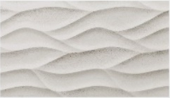 | 250x443mm | 10 mm White | Gris (grey) | Madagascar Natural  (443x443mm)  Grout = Gris
Glaciar |  | 250x443mm | 10 mm White | Blanco (white) | See further options below

Upgrade range wall tiling
These tiles are available at extra charge through your client Extras and different choices may vary in price, please see your Sales Adviser for further information.
Range/Colour |  | Tile size | Trim (not in Utility rooms / cupboards) | Grout/Sealant | Upgrade Floor Tile (recommended)
Calpe Blanco |  | 75x300mm | 10 mm White | Blanco(white) | See further options below
Calpe Seagreen |  | 75x300mm | 10 mm White | Gris (grey) | See further options below
Calpe Warm Grey |  | 75x300mm | 10 mm White | Blanco(white) | See further options below
Calpe Blanco, Calpe Seagreen and Calpe Warm Grey tiles above will be fitted in brick-bond format.
Indic | 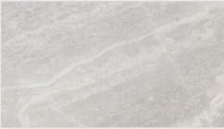 | 333x592mm | 10 mm White | Gris (grey) | Indic  443x443mm  Grout = Gris
Cubik Indic | 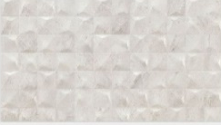 | 333x592mm | 10 mm white | Gris (grey) | Indic  443x443mm  Grout = Gris
Image Dark | 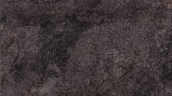 | 333x592mm | 10 mm white | Antracita | Image Dark (443x443mm)  Grout = Antracita | 
Mystic Beige | 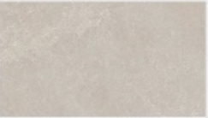 | 333x592mm | 10 mm White | Gris (grey) | Mystic Beige (443x443mm)  Grout = Gris | 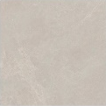
Spiga Mystic Beige | 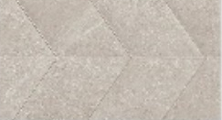 | 333x592mm | 10 mm White | Gris (grey) | Mystic Beige (443x443mm)  Grout = Gris
Mystic Grey | 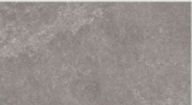 | 333x592mm | 10 mm White | Cemento (cement grey) | Mystic Grey  (443x443mm)  Grout = Cemento | 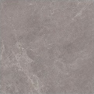
Spiga Mystic Grey | 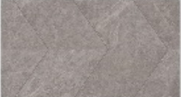 | 333x592mm | 10 mm White | Cemento (cement grey) | Mystic Grey  (443x443mm)  Grout = Cemento
Coral Caliza | 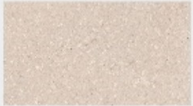 | 333x592mm | 10 mm White | Caliza | Coral Caliza  (443x443mm)  Grout = Gris | 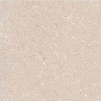
Deco Coral Caliza | 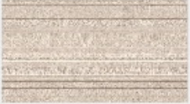 | 333x592mm | 10 mm White | Caliza | Coral Caliza  (443x443mm)  Grout = Gris
Marmol Carrara Blanco | 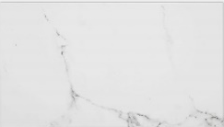 | 333x592mm | 10 mm White | Blanco(white) | Carrara Blanco Nature  (443x443mm)  Grout = Gris | 
Lexington Cognac | 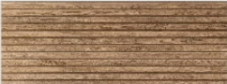 | 45x120mm | 10 mm White | Tabaco   | See further options below
Lexington Colonial | 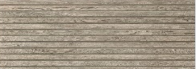 | 45x120mm | 10 mm White | Manhattan (mid grey) | See further options below

Upgrade range floor tiling (where a complementary choice is not detailed above)
These tiles are available at extra charge through your client Extras and different choices may vary in price, please see your Sales Adviser for further information.
Range/Colour | Tile size | Grout/Sealant
Indic | 443x443mm | Gris (grey) | 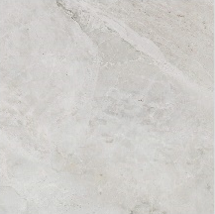
Butan Bone | 443x443mm | Gris (grey) | 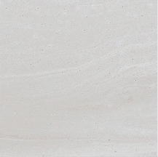
Ferroker | 443x443mm | Antracita (anthracite grey) | 
Bottega Caliza | 443x443mm | Gris (grey) | 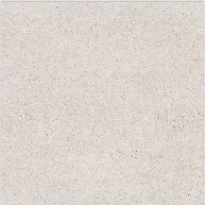
Bottega Acero | 446x446mm | Manhattan (mid grey) | 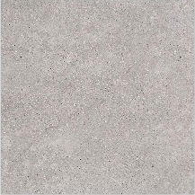
Image White | 443x443mm | Gris (grey) | 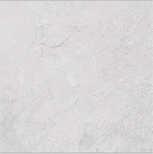
Image Silver | 443x443mm | Manhattan (mid grey) | 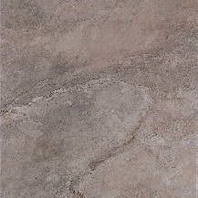
Image Dark | 443x443mm | Antracita (anthracite grey) | 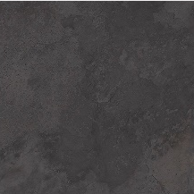
Madagascar Blanco | 443x443mm | Gris (grey) | 
Madagascar Natural | 443x443mm | Gris (grey) | 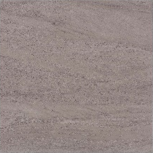
Mystic Beige | 443x443mm | Gris (grey) | 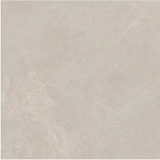
Mystic Grey | 443x443mm | Cemento (cement grey) | 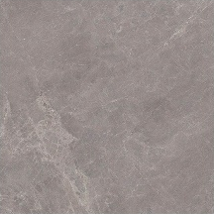
Coral Caliza | 443x443mm | Gris (grey) | 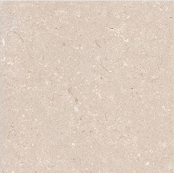
Carrara Blanco Natural | 443x443mm | Gris (grey) | 

En suite shower paneling (where applicable)
The feature wet wall paneling within the shower enclosure will be Gloss White 8100.

Sanitary ware and fitments


Sanitary ware colour (unless specified otherwise below) will be – White.
An upgrade to black finish brassware is available at additional charge. Please see house type drawings for specific layouts/details.
Ground floor Cloakroom/Shower room (where applicable) | Duravit No. 1 450mm wall hung basin with Flowstar exposed chrome bottle trap.
Ground floor Cloakroom/Shower room (where applicable) | Hansgrohe Vernis Blend 70 single lever chrome basin mixer and chrome pop-up waste.
Ground floor Cloakroom/Shower room (where applicable) | Duravit No. 1 close-coupled WC with soft-close seat.
Bathroom | Kenmore Square 1700x700mm bath with white Carron Quantum panel and pop-up waste
Bathroom | Merlyn Series Vivid 2 panel folding curved bathscreen 900x1500mm (where applicable)
Bathroom | Hansgrohe Vernis Blend Vario EcoSmart shower set with 650mm chrome shower bar and Ecostat 1001 CL thermostatic bath mixer or Vernis Blend chrome bath mixer
Bathroom | JT Fusion 1000x800mm or 1200x800mm or 1200x760mm low profile shower tray.
Bathroom | Merlyn Ionic Source 1000mm or 1200mm sliding shower door
Bathroom | Hansgrohe Vernis Blend 100 Cario EcoSmart shower set with 650mm Crometta chrome shower bar and Ecostat 1001 CL thermostatic exposed shower mixer (where applicable)
Bathroom | Duravit No. 1 back-to-wall WC with soft-close seat and Wirquin concealed cistern
Bathroom | Laings Luxe 500 or 600mm 1 drawer vanity unit, finish choices shown below, with chrome handle and inset basin.
Bathroom | Hansgrohe Vernis Blend 70 single lever chrome basin mixer and chrome pop-up waste.
En suite/s | JT Fusion 1000x800mm or 1200x800mm or 1200x760mm low profile shower tray.
En suite/s | Merlyn Ionic Source 1000mm or 1200mm sliding shower door
En suite/s | Hansgrohe Vernis Blend 100 Cario EcoSmart shower set with 650m0m Crometta chrome shower bar and Ecostat 1001 CL thermostatic exposed shower mixer
En suite/s | Duravit No. 1 back-to-wall WC with soft-close seat and Wirquin concealed cistern
En suite/s | Laings Luxe 500 or 600mm 1 drawer vanity unit, finish choices shown below, with chrome handle and inset basin.
En suite/s | Hansgrohe Vernis Blend 70 single lever chrome basin mixer and chrome pop-up waste.
The Laings Luxe/Ambiance Bain vanity unit utilises a Hettich drawer box and is available in any of the below colours, please specify. The bath panel can also be upgraded to the same colour finish, please see the Customer Upgrades document for further details. In addition, the vanity unit handle is supplied as Chrome finish as standard, this can be amended to Matt Black or Matt Gold at no extra charge.
Chamonix |  | Catania |  | Orme |  | Safari
 |  | 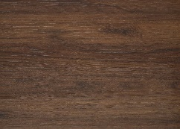 |  | 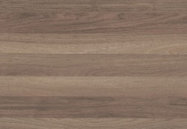 |  | 
Pompadour |  | Cashmere |  | Titane |  | Olive
 |  |  |  |  |  | 
Forest Green |  | Natural Oak
 |  | 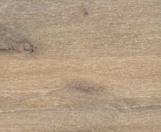
Chrome |  |  | Matt Black |  | Matt Gold
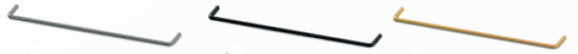
Please consult the sales adviser for further information. Not all items/details will be applicable to every situation, please review plot specific drawings when considering these options.
Although every care and attention has been taken to ensure the accuracy of all information given, the contents do not form part of or constitute a representation or warranty of any contract.
Scotia Homes Limited reserves the right to vary the above specifications (including any quoted sizes and specific products/model nos.) where necessary but to similar or higher standards.

