Bespoke Options
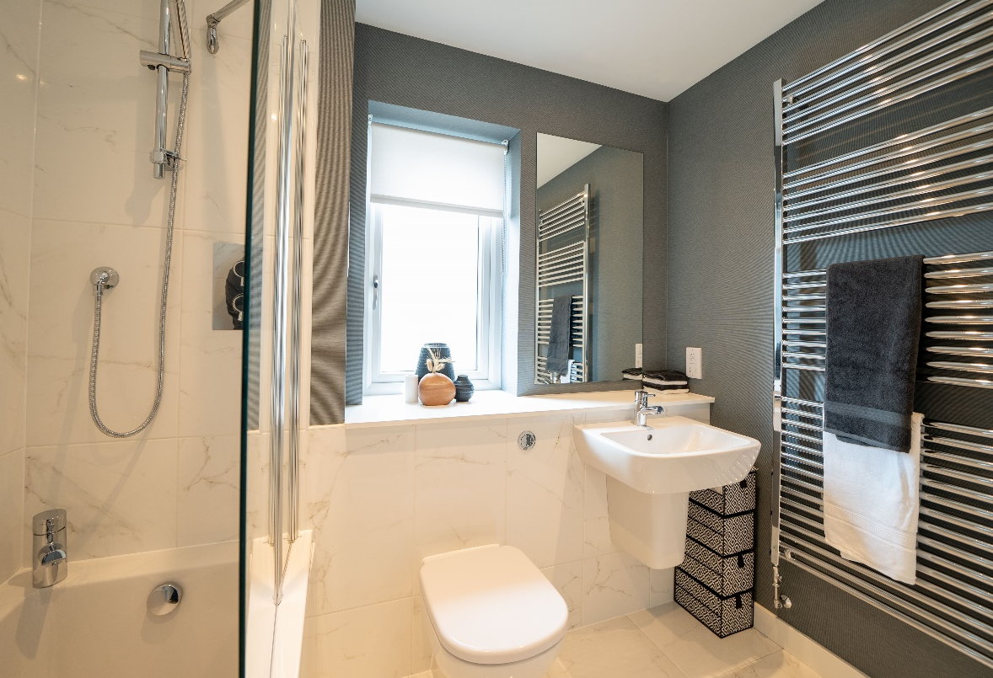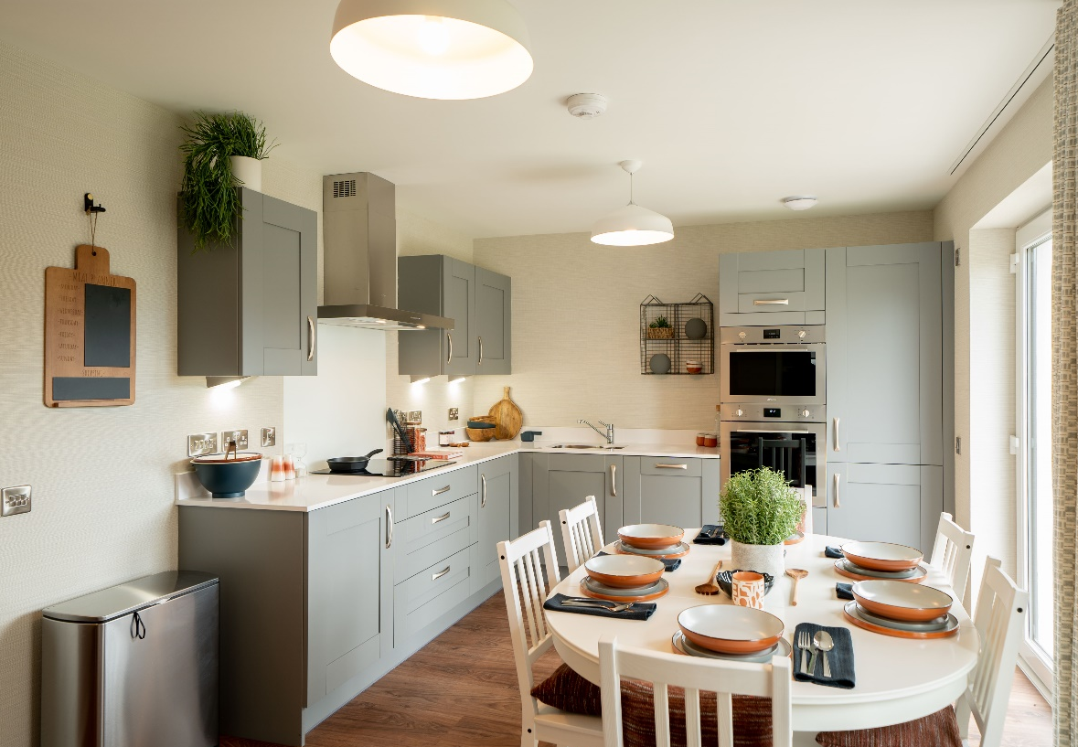
Aberfell, Arbroath

Kitchen (including Utility rooms/cupboard, where applicable)
Standard furniture
Standard Door & Drawer Fronts  SLAB DOORS |  | Complementary Cabinet inside/outside | Handle Choice (Pick one) | 40mm Premium Laminate Work Surface & Upstands
Turin Alby Blue  (18mm super matt PET foil ABS edged MFC)  |  | Grey linen interior  All exterior panels, including plinths, in Alby Blue  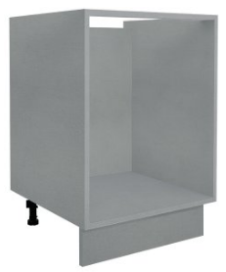 | HPK640 HPK792 HPK797  HPK859 | Arctic Marble  Chalet Oak  Grey Terrazo  Silver Oak  Venice Marble  Volcanic Ash
Urban Cobble Grey  (18mm super matt PET foil ABS edged MFC) |  | Grey linen interior  All exterior panels, including plinths, in Cobble Grey | HPK630 HPK794 HPK796 HPK957
Urban Fern Green  (18mm super matt PET foil ABS edged MFC) |  | Grey linen interior  All exterior panels, including plinths, in Fern Green | HPK630 HPK794 HPK796 HPK957
Urban Indigo  (18mm super matt PET foil ABS edged MFC) |  | Grey linen interior  All exterior panels, including plinths, in Indigo | HPK630 HPK794 HPK796 HPK957
Urban Pebble  (18mm super matt PET foil ABS edged MFC) |  | White interior  All exterior panels, including plinths, in Pebble  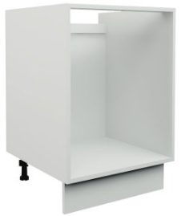 | HPK630 HPK794 HPK796 HPK957 | Arctic Marble  Chalet Oak
Urban White  (18mm super matt PET foil ABS edged MFC) |  | White interior  All exterior panels, including plinths, in White | HPK630 HPK794 HPK796 HPK957
 |  | The door and drawer fronts are made using a % of recycled chipboard.
 |  | The door and drawer fronts are made using a rPET foil made from recycled plastic bottles.
Wall units to Turin/Urban ranges will not be fitted with handles and will be inset handleless.

Kitchen (including Utility rooms/cupboard, where applicable)
Upgrade furniture (these choices are available at extra charge through your Extras, please see your Sales Adviser)
Upgrade Door & Drawer Fronts  SHAKER DOORS |  | Complementary Cabinet inside/outside | Handle Choice (Pick one) | 40mm Premium Laminate Work Surface & Upstands
Harvard Alby Blue  (19mm MDF narrow frame smooth PVC one piece shaker) |  | Riviera interior  All exterior panels, including plinths, in Alby Blue | HPK644 HPK794 HPK796 HPK957 | Arctic Marble  Chalet Oak  Grey Terrazo  Silver Oak  Venice Marble  Volcanic Ash
Harvard Hunter Green  (19mm MDF narrow frame smooth PVC one piece shaker) |  | Riviera interior  All exterior panels, including plinths, in Hunter Green | HPK644 HPK794 HPK796 HPK957
Harvard Pebble  (19mm MDF narrow frame smooth PVC one piece shaker) | 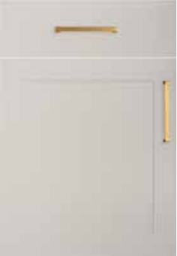 | Riviera interior  All exterior panels, including plinths, in Pebble | HPK644 HPK794 HPK796 HPK957
Langdale Fern Green  (22mm grained foil wrapped five-piece MDF shaker) |  | Riviera interior  All exterior panels, including plinths, in Fern Green | HPK644 HPK794 HPK859 HPK907
Langdale Harbour Grey  (22mm grained foil wrapped five-piece MDF shaker) |  | Riviera interior  All exterior panels, including plinths, in Harbour Grey | HPK644 HPK794 HPK859 HPK907
Langdale Indigo  (22mm grained foil wrapped five-piece MDF shaker) |  | Riviera interior  All exterior panels, including plinths, in Indigo | HPK644 HPK794 HPK859 HPK907

Upgrade Door & Drawer Fronts  GLOSS HANDLELESS DOORS |  | Complementary Cabinet inside/outside | Handle Choice | 40mm Premium Laminate Work Surface & Upstands
New York Gloss Dusk Grey  (22mm gloss painted and lacquered MDF) |  | Grey linen interior  All exterior panels, including plinths, in Gloss Dusk Grey | Handleless | Arctic Marble  Chalet Oak  Grey Terrazo  Silver Oak  Venice Marble  Volcanic Ash
New York Gloss Pearl Grey  (22mm gloss painted and lacquered MDF) |  | Grey linen interior  All exterior panels, including plinths, in Gloss Pearl Grey | Handleless
New York Gloss White  (22mm gloss painted and lacquered MDF) |  | White interior  All exterior panels, including plinths, in Gloss White | Handleless
Upgrade Wall Door fronts
ACCENT FEATURE (WALL UNITS ONLY)
Costina Fresca  (18mm ribbed effect ABS edged MFC) | 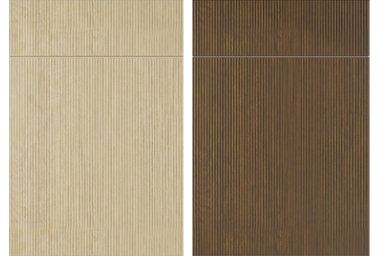 | Colour of interior will match base & tall units.  All exterior panels, in Fresca | Inset handleless
Costina Noce  (18mm ribbed effect ABS edged MFC) |  | Colour of interior will match base & tall units.  All exterior panels, in Noce | Inset handleless

Handle Options
Handles are range specific and only one handle choice can be selected from the below.
TURIN | URBAN | HARVARD | LANGDALE
HPK640  Chrome Chunky Bridge Handle  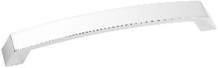 | HPK630  Brushed Nickel Barrel D Handle  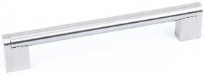 | HPK644  Matt Nickel Square D Handle  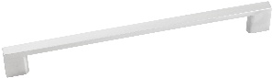 | HPK644  Matt Nickel Square D Handle
HPK792  Brushed Copper Bridge Handle  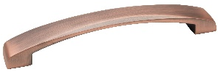 | HPK794  Antique Copper Bow Handle  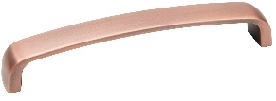 | HPK794  Antique Copper Bow Handle | HPK794  Antique Copper Bow Handle
HPK797  Gloss Black Square Handle  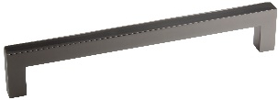 | HPK796  Brushed Bronze Arched Bridge Handle  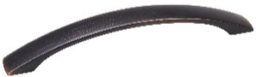 | HPK796  Brushed Bronze Arched Bridge Handle | HPK907  Camden Matt Black Handle  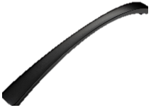
HPK859  Matt Brass Arched Bridge Handle  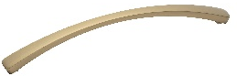 | HPK957  Rose Gold Square Handle  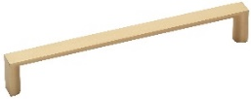 | HPK859  Matt Brass Arched Bridge Handle
Wall units to Turin/Urban ranges will not be fitted with handles and will be inset handleless.

U Upgrade 22mm Laminate Work Surfaces & Upstands
These choices are available at extra charge through your Extras and represent a range of thinner 22mm laminate work surfaces.
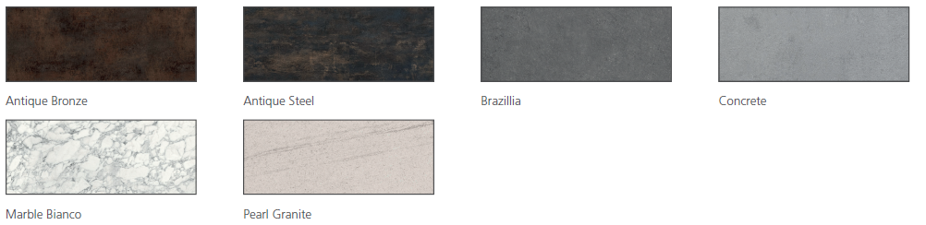

Upgrade 20mm Quartz Work surfaces & Upstands †
These choices are available at extra charge through your Extras and represent a premium range of 20mm composite quartz work surfaces.
† Different colour choices may vary in price, these items will be priced on request
Blanco Norte (PB1) | Obsidiana Volcano Cloud (PB1) | Obsidiana Volcano Pearl (PB1) | Obsidiana Volcano Dark (PB1)
Coral Clay (PB2) | Carrara (PB2) | Stellar Blanco (PB2) | White Storm (PB2)
Unique Arabescato (PB3) | Unique Venantino (PB3) 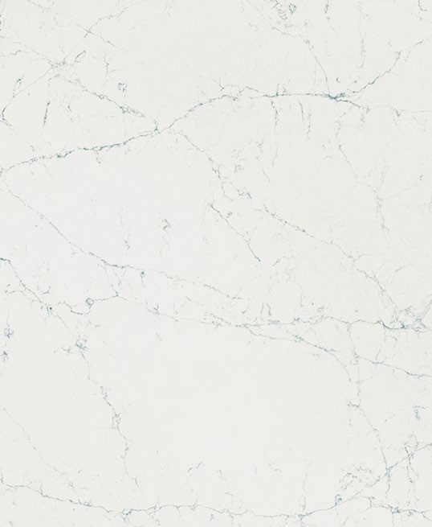 | Charcoal Soapstone (PB3) | White Arabesque (PB3)
Worktops are supplied in maximum lengths depending on the range chosen, which may result in joints, some of which may be conspicuous due to adjacent angles and the variation of pattern and colour within each finsh.

Choice of glass panel splashback (behind hob)
Toughened glass splashbacks are manufactured with 6mm heat and UV resistant glass and come with polished edges for safety. Additional/non-standard sizes may not be toughened glass and will incur additional cost due to additional templating and installation requirements.
Silver | Cashmere | Dusky Pink | Merlot | White Sparkle
Metallic Charcoal | Dakar Yellow | Platinum | Mineral | Anthracite
Blue | Storm Blue | Indigo | Mono Bride | Mono Pewter
Mono White | Mono Ebony
On screen and printed colours may vary slightly from the actual product, please refer to physical samples for colour matching.

Sinks and Taps
Kitchen: | Rangemaster Glendale GL9502 stainless steel 1½ bowl sink with Bristan Odyssey monobloc sink mixer with single flow spout
Utility Room (where applicable and fitted): | Rangemaster Glendale GL9501 stainless steel 1 bowl sink sink with Bristan Odyssey monobloc sink mixer with single flow spout

Appliances
Fitted as standard is a black electric oven, electric induction hob, contemporary style extractor hood and an integrated fridge/freezer.
- | Smeg SF6100VB3 - single black fan oven
- | Smeg SI2641D 60cm induction hob or SI2741D 75cm or HOBD472D 70cm/HOBD472D venting induction hob, depending on layout
- | Smeg KI52E3 52cm or KSG73E 73cm canopy recirculation extractor hood, depending on layout
- | Smeg UKC81721E 70/30 tall fridge/freezer
At an additional charge an upgrade to some of the kitchen/utility room packages can be fitted. This may be subject to house type and can include additional appliances i.e. combination microwave/oven, integrated dishwasher, and/or a free-standing washer/dryer – please ask the Sales Adviser for details.

Bathroom (including En Suite shower room/s)
Whilst the choice of wall tiling is entirely your own, we recommend that you consider the size of individual tiles when considering locations, as this may have an effect on both the visual appearance, and also the need for ‘cut’ tiles upon installation.
Where orientation is not specifically confirmed on your colour choice requests, these will be fitted ‘portrait’ to bathrooms/en suites, where applicable. This may have an effect on the visual appearance, as noted above.
N.B. Whilst all floor (available as an upgrade through your Extras) tiles listed are suitable for general internal floor use, further advice must be sought with regard to slip ratings if these are to be installed in a ‘wet’ floor environment.

Standard range wall tiling
Range/Colour |  | Tile size | Trim (not in Utility rooms / cupboards) | Grout/Sealant | Upgrade Floor Tile (recommended)
Indic | 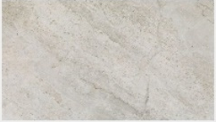 | 250x443mm | 10 mm White | Gris (grey) | Indic (443x443mm)  Grout = Gris | 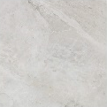
Butan Bone | 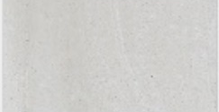 | 250x443mm | 10 mm White | Gris (grey) | Butan Bone  (443x443mm)  Grout = Gris | 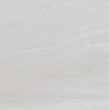
Shine Dark | 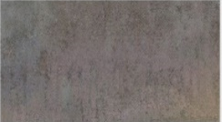 | 250x443mm | 10 mm White | Antracita | Ferroker  (443x443mm)  Grout = Antracita | 
Bottega Caliza | 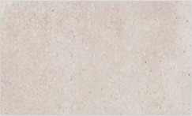 | 250x443mm | 10 mm White | Caliza   | Bottega Caliza  (443x443mm)  Grout = Gris | 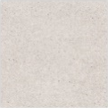
Bottega Acero | 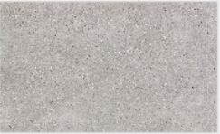 | 250x443mm | 10 mm White | Manhattan (mid grey) | Bottega Acero  (443x443mm)  Grout = Manhattan | 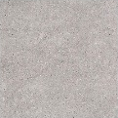
Image White |  | 250x443mm | 10 mm White | Blanco (white) | Image White (443x443mm)  Grout = Gris | 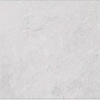
Image Silver | 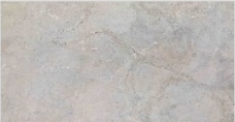 | 250x443mm | 10 mm White | Manhattan (mid grey) | Image Silver (443x443mm)  Grout = Maanhattan | 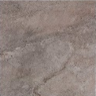
Madagascar Blanco | 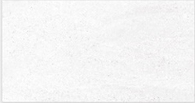 | 250x443mm | 10 mm White | Blanco (white) | Madagascar Blanco  (443x443mm)  Grout = Gris | 
Madagascar Natural |  | 250x443mm | 10 mm White | Gris (grey) | Madagascar Natural  (443x443mm)  Grout = Gris | 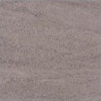
Ona Blanco | 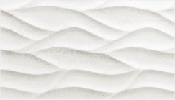 | 250x443mm | 10 mm White | Blanco (white) | Madagascar Blanco  (443x443mm)  Grout = Gris
Ona Natural | 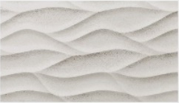 | 250x443mm | 10 mm White | Gris (grey) | Madagascar Natural  (443x443mm)  Grout = Gris
Glaciar |  | 250x443mm | 10 mm White | Blanco (white) | See further options below

Upgrade range wall tiling
These tiles are available at extra charge through your client Extras and different choices may vary in price, please see your Sales Adviser for further information.
Range/Colour |  | Tile size | Trim (not in Utility rooms / cupboards) | Grout/Sealant | Upgrade Floor Tile (recommended)
Calpe Blanco |  | 75x300mm | 10 mm White | Blanco(white) | See further options below
Calpe Seagreen |  | 75x300mm | 10 mm White | Gris (grey) | See further options below
Calpe Warm Grey |  | 75x300mm | 10 mm White | Blanco(white) | See further options below
Calpe Blanco, Calpe Seagreen and Calpe Warm Grey tiles above will be fitted in brick-bond format.
Indic | 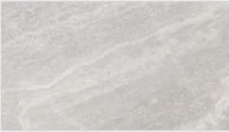 | 333x592mm | 10 mm White | Gris (grey) | Indic  443x443mm  Grout = Gris
Cubik Indic | 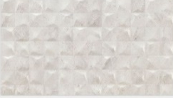 | 333x592mm | 10 mm white | Gris (grey) | Indic  443x443mm  Grout = Gris
Image Dark | 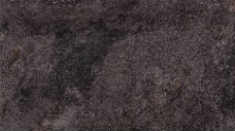 | 333x592mm | 10 mm white | Antracita | Image Dark (443x443mm)  Grout = Antracita | 
Mystic Beige | 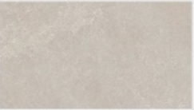 | 333x592mm | 10 mm White | Gris (grey) | Mystic Beige (443x443mm)  Grout = Gris | 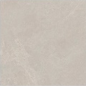
Spiga Mystic Beige | 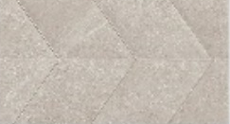 | 333x592mm | 10 mm White | Gris (grey) | Mystic Beige (443x443mm)  Grout = Gris
Mystic Grey | 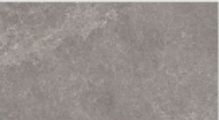 | 333x592mm | 10 mm White | Cemento (cement grey) | Mystic Grey  (443x443mm)  Grout = Cemento | 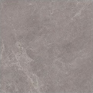
Spiga Mystic Grey | 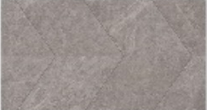 | 333x592mm | 10 mm White | Cemento (cement grey) | Mystic Grey  (443x443mm)  Grout = Cemento
Coral Caliza | 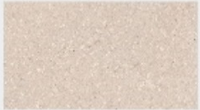 | 333x592mm | 10 mm White | Caliza | Coral Caliza  (443x443mm)  Grout = Gris | 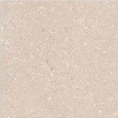
Deco Coral Caliza | 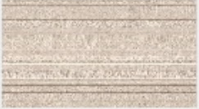 | 333x592mm | 10 mm White | Caliza | Coral Caliza  (443x443mm)  Grout = Gris
Marmol Carrara Blanco | 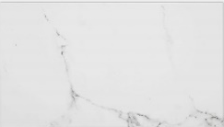 | 333x592mm | 10 mm White | Blanco(white) | Carrara Blanco Nature  (443x443mm)  Grout = Gris | 
Lexington Cognac | 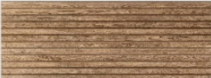 | 45x120mm | 10 mm White | Tabaco   | See further options below
Lexington Colonial | 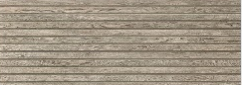 | 45x120mm | 10 mm White | Manhattan (mid grey) | See further options below

Upgrade range floor tiling (where a complementary choice is not detailed above)
These tiles are available at extra charge through your client Extras and different choices may vary in price, please see your Sales Adviser for further information.
Range/Colour | Tile size | Grout/Sealant
Indic | 443x443mm | Gris (grey) | 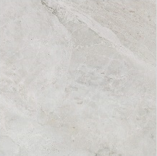
Butan Bone | 443x443mm | Gris (grey) | 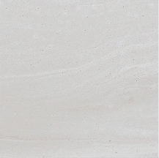
Ferroker | 443x443mm | Antracita (anthracite grey) | 
Bottega Caliza | 443x443mm | Gris (grey) | 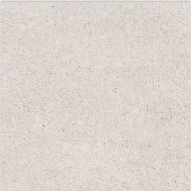
Bottega Acero | 446x446mm | Manhattan (mid grey) | 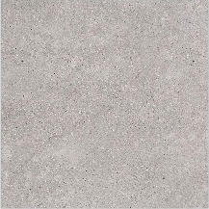
Image White | 443x443mm | Gris (grey) | 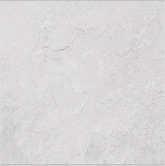
Image Silver | 443x443mm | Manhattan (mid grey) | 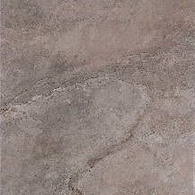
Image Dark | 443x443mm | Antracita (anthracite grey) | 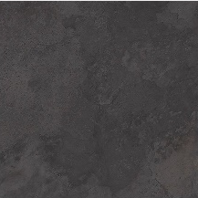
Madagascar Blanco | 443x443mm | Gris (grey) | 
Madagascar Natural | 443x443mm | Gris (grey) | 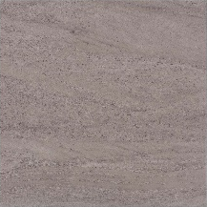
Mystic Beige | 443x443mm | Gris (grey) | 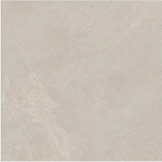
Mystic Grey | 443x443mm | Cemento (cement grey) | 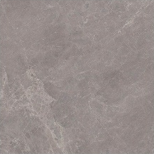
Coral Caliza | 443x443mm | Gris (grey) | 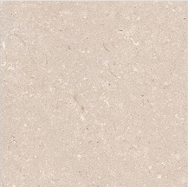
Carrara Blanco Natural | 443x443mm | Gris (grey) | 

Sanitary ware and fitments
Sanitary ware colour will be – White.
Ground floor Toilet (where applicable) | Armitage Shanks i.life range white 1 tap hole wall mounted basin with semi pedestal or corner basin.
Ground floor Toilet (where applicable) | Bristan Prism basin mixer with chrome waste kit.
Ground floor Toilet (where applicable) | Armitage Shanks i.life range white close-coupled W.C. complete with soft-close seat and cover.
Bathroom | Armitage Shanks i.life range white 1700x700mm 1 tap hole bath
Bathroom | Ideal Standard Unilux E3194 white bath panel.
Bathroom | Bristan Prism bath filler.
Bathroom | Chrome plated luxury bath pop-up waste kit.
Bathroom | Bristan Prism thermostatic dual control shower valve and quadrant shower kit (where fitted)
Bathroom | Armitage Shanks i.life range white 1 tap hole wall mounted basin with semi pedestal.
Bathroom | Bristan Prism basin mixer with chrome waste kit.
Bathroom | Armitage Shanks i.life range white back to wall WC with concealed cistern, dual flushing button, soft-close seat and cover.
Bathroom | Lakes Classic or Novellini Aurora 3 – 2 panel 960mm x 1500mm clear glass bath splash screen (where fitted)  (Where a separate shower cubicle is also fitted, please see En suite detail)
En suite  (where applicable) | Armitage Shanks i.life range white 1 tap hole wall mounted basin with semi pedestal.
En suite  (where applicable) | Bristan Prism basin mixer with chrome waste kit.
En suite  (where applicable) | Armitage Shanks i.life range white back to wall WC with concealed cistern, dual flushing button, soft-close seat and cover.
En suite  (where applicable) | Just Fusion shower tray with wall panel & Ideal Standard Synergy chrome/clear glass enclosure.
En suite  (where applicable) | Bristan Prism thermostatic dual control shower valve and adjustable riser.

En suite shower paneling (where applicable)
The feature wet wall paneling within the shower enclosure will be Gloss White 8100.
Please consult your Sales Adviser for further information. Not all items/details will be applicable to every situation, please review plot specific drawings when considering these options.
Although every care and attention has been taken to ensure the accuracy of all information given, the contents do not form part of or constitute a representation or warranty of any contract.
Scotia Homes Limited reserves the right to vary the above specifications (including any quoted sizes and specific products/model nos.) where necessary but to similar or higher standards.

