Customer Upgrades

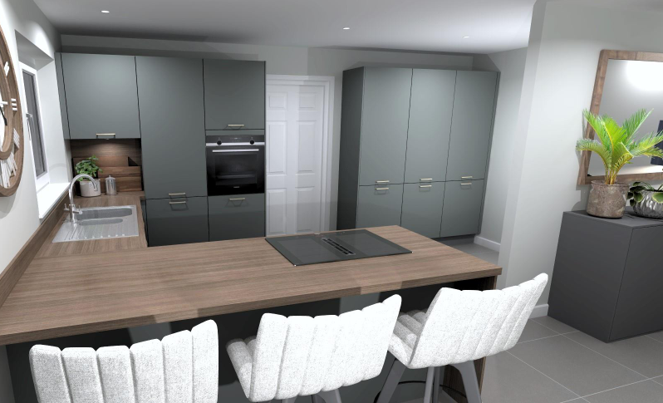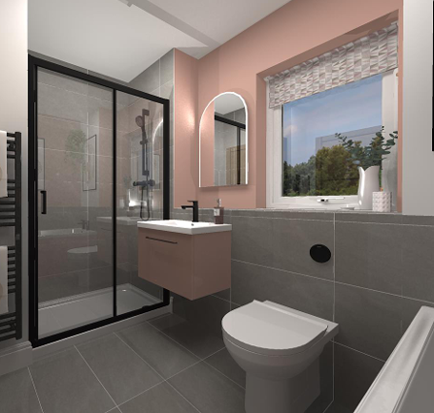
Dalfaber, Aviemore
(Plots 038-039, 041-044 & 065-071)
When you choose to buy a new Scotia home, you will be offered, subject to stage of construction, the opportunity to request a range of upgrade items (Extras).
Client:
Plot number:
Property type:
Sales advisor:
Date:

Conditions for acceptance of upgrade requests
- Not all the items on the list may be either appropriate or available for particular specifications and/or phases of developments. The opportunity for structural alterations will be subject to confirmation of suitability of site/ground conditions, building programme and in some instances may not be available at all.
- The prices shown exclude any Planning, Amendment to Building Warrant, architect’s or engineer’s fees which may be incurred, and please be aware that in some instances, even a ‘no charge’ item which requires a change to the Building Warrant may incur these fees. We will endeavour to inform you as soon as relevant applications are made and fees confirmed.
- Where exact specification and/or model is detailed within an item e.g. kitchen appliances, these are subject to availability and suitability, these may be replaced my models of equivalent or superior specification.
- The cost of all upgrades shall be payable at the time of acceptance of the quotation and instruction to proceed.
- This document lists all the possible alterations and upgrades that can be made to your home. We ask that you read through the possibilities and consider which, if any, of the upgrades you would like to include in your new home.
- Once you have read through the available upgrades please put a tick in the ‘proceed’ column for any items you know you wish to proceed with. If there are any items you are considering but require clarification on, make a mark next to the item and your sales advisor can discuss the option with you at your Extras/Options appointment.
- You will see that each request has been allocated an item number. In the case of multiple requests for the same item these should be numbered e.g. 2, 2.1, 2.2 etc. Where more requests for the same item are required please use the continuation sheet at the end of this form, carrying on the appropriate numbering system i.e. 2.3, 2.4 etc. Where a request refers to a specific item or location (e.g. a light switch or a wardrobe) please mark this on the scale drawing of your property provided by drawing a
- line to the specific location and adding the corresponding number to the end of the line so we can be sure we understand your request. It is essential that specific location information is provided at the time
- of request/confirmation or ‘standard’ detail may be assumed, information or changes provided at a later date may incur additional cost for revision to drawings/instructions, or may not be possible.
- All prices quoted as per item. You do not need to write out additional prices, or total up the cost of multiple requests, but these will be itemized and a total given on your final lists of extras (Quotation) that
- will be sent to you upon completion of your Extras/Options appointment and after checking and pricing by our Technical team.
- As explained by your sales advisor and as mentioned in your Reservation file, the time for requesting and agreeing extras is crucial and in most circumstances governed by the terms of the Missives, so please take this opportunity to fully consider your requests from the list provided.
- Any requests for items not shown on the form will not be considered and we reserve the right to refuse items without justification.
- Please note that all requests are subject to confirmation by Scotia that they do not breach any Local Authority/Health & Safety/Building Control/ NHBC Regulations. We will of course advise you if this is the case or if your requests could have an effect on any of the aforementioned.
- Upon issue of your final list of extras (Statement) no further requests will be considered.
- Where, in exceptional circumstances, a late amendment to extras is agreed, this will be subject to a minimum administration fee of £50.00, which will be increased to £150.00 where revised drawings and instructions are needed.

Extras/Upgrades
Item | Description | Price | Room/Position/Comments | Proceed
PLEASE ENSURE ALL ITEM NUMBERS ARE REFERRED TO ON ACCOMPANYING DRAWINGS
Major/Minor items
ALTMA92.1 | Supply and fit Garamatic 10 electric garage door opener to standard garage door.  This to include:  Garamatic10 opener with 2 x handsets and Bluetooth functionality.  Fitting of electric supply on garage ceiling c. 3000mm back from garage door. | £716
ALTMI23 | Supply and fit dwangs for flat screen TV in XXXX, as per plan - position, height and dimensions to be confirmed by client with return of instructions. Scotia standard dimensions are: Electrician's dwang 560mm wide x 100mm high, with TV dwang 560mm wide x 400mm high above as per drawing SHN-SALES-01. | £65
Electrical items
ELE10 | Supply and fit white electric toothbrush charger with shaver point (Proof PV12P) in lieu of standard shaver point.  Add £14 if polished steel, brushed steel or matt black faceplate is required. | £38
ELE40 | Supply and fit additional power supply inside/outside (£50 additional charge) garage/or alternate point adjacent to owned parking area (delete as necessary) to enable client's own contractor to supply and fit electric vehicle charging unit after settlement.  This to include:  Upgrading of standard consumer unit within garage (or house where units are not separated) to provide additional capacity which can be individually isolated.  Provision of cabling between consumer unit and point no more than 10m from consumer unit, to be terminated in new weatherproof junction box for future connection.  All of above based on provision of supply at 7kW (30A) rating.  NOTE:  This item provides for additional power supply based on specification above only and with no liability for future connection/s and/or variation to requirements.  Should this be located in a garage detached from main house, this will be subject to separate charge of £527. | £253
ELE41 | Supply and fit Wallbox Pulsar Max 7.4kW EV charger to (please specify required wall-mounted location - standard 5m cable).  NOTE:  Type 2 charger will be fitted as standard, please specify if Type 1 is required. | £945
ELE42 | Supply and fit Wallbox Pulsar Max 7.4kW EV charger including EV Blocks installation block, mounting pedestal and required additional cabling/concrete base/groundworks (please specify location - standard 5m cable).  NOTE:  Type 2 charger will be fitted as standard, please specify if Type 1 is required. | £1998
ELE46 | Supply and fit additional TV point at standard height in XXXX, as per drawing. | £75
ELE47 | Supply and fit 8-way digital TV amplifier, including switched socket, adjacent to consumer unit (excluding aerial in developments without communal digital TV/satellite feed) - allows up to 8 TV points. | £175
ELE48 | Supply & fit HDMI (high-definition multimedia interface) cable (within wall, with c.300mm of spare cable to allow future connection at either end) from low level/position of item XX to electrician's dwang of item XX in XXXX, as per drawing.  NOTE:  Price for this item is based on a single straight, vertical cable run of no more than 2m overall length and variations to this cannot be considered. | £75
ELE52U | Supply and fit additional double power point with inbuilt USB charging point at standard height in XXXX, as per drawing. | £95
ELE52Ua | Supply and fit white power point with inbuilt USB charging point in lieu of existing double power point in XXXX, as per drawing. | £35
ELE53 | Supply and fit additional double power point in garage, as per drawing, including surface mounting and any additional surface ducting required. | £85
ELE54 | Supply and fit external double power point, as per drawing | £185
ELE60 | Supply and fit electric spur point for future fitting of client's own alarm. | £85
ELE63 | Supply and fit XX x 7 watt energy saving LED white downlighters in lieu of standard pendant/s in XXXX, as per drawing.  Please mark required positions on drawing, recommended spacing for 'normal' lighting 1.2m.  PRICE IS PER INDIVIDUAL DOWNLIGHTER  NOTE: Fittings will be installed White finish as standard, please specify if Polished Chrome or Satin Chrome finish is preferred. In addition, colour temperature will be set to Warm White as standard, please specify if Cool White or Daylight is preferred (no additional charge). | £90
ELE65 | Upgrade finish of electrical points from standard white to polished chrome/satin chrome (DELETE AS REQUIRED – default will be satin chrome if no detail is provided). Please also specify whether white / black / grey inserts are preferred – default will be white if no detail is provided. Grey inserts are not available with polished chrome finish). | Priced on request
ELE98 | Supply and fit additional standard external wall-mounted light fitting (style applicable to public elevations) as per drawing (new switch included, please specify required location of switch also). | £130
ELE99 | Supply and fit additional standard external wall-mounted light fitting (style applicable to private elevations) as per drawing (new switch included, please specify required location of switch also). | £120
Kitchen items
KITAL68 | Supply and fit upgraded 20mm Diore Quartz (please specify colour choice) worktop and splashback/upstand/s in Kitchen, including omission of standard inset sink and supply and fit of Blanco Solis 340/160U under-mounted sink with drainage to the worktop in lieu of standard.  NOTE: Please be aware that quartz work surfaces are by compound made up of natural stone/minerals. This means that minor imperfections in colour and finish may be present, these variations in surface aesthetics do not represent a defect.  Drainer grooves may not have as highly polished a finish as the rest of the surface. | Priced on request
KITAL68.1 | Supply and fit upgraded 20mm Diore Quartz (please specify colour choice) worktop and splashback/upstand/s in Utility Room, including omission of standard inset sink and supply and fit of Blanco Solis 500U under-mounted sink with drainage to the worktop (where applicable) in lieu of standard. | Priced on request
KITAL82 | Supply and fit upgraded beech wood cutlery tray in lieu of standard synthetic tray in Kitchen. | £105
KITAL84.2 | Supply and fit upgraded Kitchen and Utility door fronts in lieu of standard.  Please specify colour choice: | Please see separate plot costings available via your sales adviser
KITAL84.3 | Supply and fit upgraded Kitchen and Utility door handles in lieu of standard.  Please specify colour choice: | Please see separate plot costings available via your sales adviser
KITAL86 | Supply and fit upgraded Le Mans corner pull-out unit in lieu of standard straight corner unit with shelves.  NOTE: Not available in the Watt house type | £774
KITAL87 | Supply and fit upgraded waste bin pull-out unit in lieu of standard 600mm base unit with shelves.  Waste bin unit includes 2 x 8L and 2 x 32L sub-compartments.  NOTE: Unit available to Napier & McAdam house types will be a 500mm unit with reduced inserts at £499 | £596
KITAL88 | Supply and fit upgraded Blanco Silgranit Sona 6 S sink and Mida tap in lieu of standard in Kitchen.  Please specify which colour choice is required:  Volcano Grey / Black / White / Anthracite / Soft White / Coffee  NOTE: Where separate upgrade to Quartz worktop is also chosen, this item will still be supplied as inset model, under-mounted version requires to be priced separately. | £342
KITAL89 | Supply and fit upgraded Quooker Fusion Square boiling water tap in lieu of standard in Kitchen.  Please specify which colour choice is required:  3FSCHR Chrome  3FSRVS Stainless Steel  3FSBLK Black  3FSGME Gun Metal  3FSPTN Patinated Brass  3FSGLS Gold  NOTE: Base price shown is for 3FSCHR Chrome version, with other colours being subject to additional pricing on a sliding scale, 3FSGLS Gold being the premium colour at £2386. | £1206-2186
KITAP77.2 | Supply and fit Smeg SO4101M1B3 Combination Oven/Microwave, with grill, above oven in appropriate tall unit in kitchen.  THIS ITEM NOT AVAILABLE IN CONJUNCTION WITH ITEM KITAP77.3, PLEASE SELECT ITEM KITAP77.4 IN THAT CASE | £1327
KITAP77.3 | Supply and fit upgraded Smeg SOP6102TB3 pyrolytic single oven, with grill, in lieu of standard in Kitchen. | £494
KITAP77.4 | Supply and fit Smeg SO4102M1B3 Combination Oven/Microwave, with grill, above oven in appropriate tall unit in kitchen.  THIS ITEM ONLY AVAILABLE IN CONJUNCTION WITH ITEM KITAP77.3 | £1445
KITAP70 | Supply and fit Smeg WDI14C7-2 60cm 7/4kg integrated washer/dryer to washing machine space, as per drawing. | £895
KITAP76 | Supply and fit Smeg WDN064SLDUK 60cm 10/6kg steam white freestanding washer/dryer to washing machine space, as per drawing. | £874
KITAP76.1 | Supply and fit Hotpoint NDB8635W UK 8/6kg white freestanding washer/dryer to washing machine space, as per drawing. | £566
KITAP78 | Supply and fit Smeg WNP84SECUK 60cm 8kg white freestanding washing machine to washing machine space, as per drawing. | £535
KITAP78.2 | Supply and fit Hotpoint NSWF7469W UK 60cm 7kg white freestanding washing machine to washing machine space, as per drawing. | £422
KITAP79 | Supply and fit Smeg DNP83SEUK 60cm 8kg heat pump condenser tumble dryer white to tumble dryer space, as per drawing. | £645
KITAP79.1 | Supply and fit Hotpoint C HD C92 WWGD UK 9kg white freestanding tumble dryer to tumble dryer space, as per drawing. | £429
KITAP90 | (Where appliance space has vertical clearance above)  Omit any worktop over appliance space, supply and fit appropriate double plumbing and electrics, along with Smeg KITSPNC stacking kit for dual laundry appliances (washing machine lower/tumble dryer upper). Where items KITAP78/79 are selected, all items will be installed accordingly, otherwise installation and connection of future appliances remains the purchaser’s responsibility. | £131
KITAP101 | Supply, and leave in Kitchen at handover, Smeg ‘50s style 1.7L 3000W fast boiling electric kettle.  Please choose from colours:  KLF03BLUK Black  KLF03WHUK White  KLF03CRUK Cream  KLF03GRUK Slate Grey  KLF03PBUK Pastel Blue  KLF03PGUK Pastel Green  KLF03PKUK Pink  KLF03RDUK Red | £119
KITAP102 | Supply, and leave in Kitchen at handover, Smeg ‘50s style 2 slice electric toaster.  Please choose from colours:  TSF01BLUK Black  TSF01WHUK White  TSF01CRUK Cream  TSF01GRUK Slate Grey  TSF01PBUK Pastel Blue  TSF01PGUK Pastel Green  TSF01PKUK Pink  TSF01RDUK Red | £119
Plumbing items
PLU10 | Supply and fit upgraded black brassware to GF Cloakroom, to include black finish; toilet flush push button, basin mixer tap and waste, bottle tap. | £143
PLU11 | Supply and fit upgraded black brassware to Bathroom, to include black finish; toilet flush push button, basin mixer tap and waste, bath filler and waste or bath/shower filler, shower rail, waste and shower screen and/or shower valve/riser, waste and sliding door. | £339  (£526 where there is separate shower cubicle).
PLU12 | Supply and fit upgraded black brassware to En Suite/2, to include black finish; toilet flush push button, basin mixer tap and waste, shower valve/riser, waste and sliding door. | £493
PLU20 | Supply and fit upgraded coloured bath panel in lieu of standard, please choose from available (to match vanity unit) colours below:  Chamonix / Catania / Pearl Grey / Safari / Pompadour / Cashmere / Titane / Regal / Forest Green / Natural Oak / Olive / Orme | £47
PLU87 | Supply and fit Pisa Plus pearl silver / white / black / anthracite (delete as necessary) finish straight heated towel rail in lieu of standard radiator in Bathroom.  NOTE: Where the standard radiator is positioned beneath a tall window, the position may require to be moved to allow for greater height requirements of towel rail.  Size will vary depending on the required heat output for room. | £473
PLU87.1 | Supply and fit Pisa Plus pearl silver / white / black / anthracite (delete as necessary) finish straight heated towel rail in lieu of standard radiator in En Suite.  NOTE: Where the standard radiator is positioned beneath a tall window, the position may require to be moved to allow for greater height requirements of towel rail.  Size will vary depending on the required heat output for room. | £473
LAN103 | Supply and lay additional turf, including necessary preparatory work, to whole of rear garden, excluding areas that are slabbed as standard, as per drawing. | Please see separate plot costings available via your sales adviser
Tiling items
TIL25 | Supply and fit one row of wall tiling above sink in GF Toilet. | £71
TIL89 | Supply and fit Porcelanosa XcolourX floor tiles in Bathroom. (Grouting will be Porcelanosa Butech Grey)  NOTE - To include suitable underlay for locations above ground floor only | Priced on request
TIL89.1 | Supply and fit Porcelanosa XcolourX floor tiles in En Suite. (Grouting will be Porcelanosa Butech Grey)  NOTE - To include suitable underlay for locations above ground floor only | Priced on request
TIL89.2 | Supply and fit Porcelanosa XcolourX floor tiles in En Suite 2. (Grouting will be Porcelanosa Butech Grey)  NOTE - To include suitable underlay for locations above ground floor only | Priced on request
TIL89.3 | Supply and fit Porcelanosa XcolourX floor tiles in GF Toilet. (Grouting will be Porcelanosa Butech Grey) | Priced on request
TIL89.4 | Supply and fit upgraded Porcelanosa wall tiles in Bathroom. Please specify colour choice. | £195
TIL89.5 | Supply and fit upgraded Porcelanosa wall tiles in En Suite. Please specify colour choice. | £145
TIL89.6 | Supply and fit upgraded Porcelanosa wall tiles in En Suite 2. Please specify colour choice. | £145
Signature of client:
Date:
Signature of sales advisor:
Date:
We look forward to helping you to personalize your new home. We will be in touch shortly to confirm if all of your requests are possible and provide any further details and pricing. We will then, pending payment, await your instructions to start the process of tailoring your new property.

