Customer Upgrades
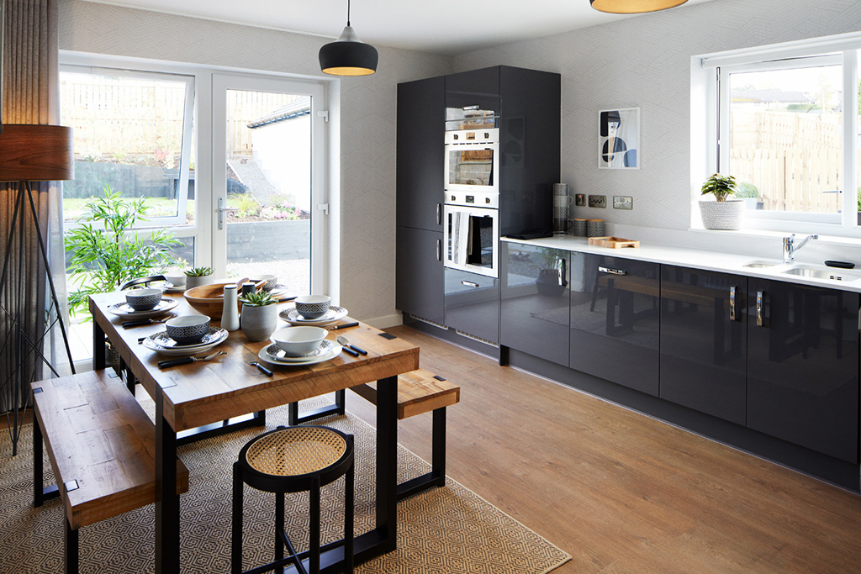
When you choose to buy a new Scotia home, you will be offered, subject to stage of construction, the opportunity to request a range of upgrade items (Extras).
Development:
Client:
Plot number:
Property type:
Sales advisor:
Date:

Conditions for acceptance of upgrade requests
- Not all the items on the list may be either appropriate or available for particular specifications and/or phases of developments. The opportunity for structural alterations will be subject to confirmation of suitability of site/ground conditions, building programme and in some instances may not be available at all.
- The prices shown exclude any Planning, Amendment to Building Warrant, architect’s or engineer’s fees which may be incurred, and please be aware that in some instances, even a ‘no charge’ item which requires a change to the Building Warrant may incur these fees. We will endeavour to inform you as soon as relevant applications are made and fees confirmed.
- Where exact specification and/or model is detailed within an item e.g. kitchen appliances, these are subject to availability and suitability, these may be replaced my models of equivalent or superior specification.
- The cost of all upgrades shall be payable at the time of acceptance of the quotation and instruction to proceed.
- This document lists all the possible alterations and upgrades that can be made to your home. We ask that you read through the possibilities and consider which, if any, of the upgrades you would like to include in your new home.
- Once you have read through the available upgrades please put a tick in the ‘proceed’ column for any items you know you wish to proceed with. If there are any items you are considering but require clarification on, make a mark next to the item and your sales advisor can discuss the option with you at your Extras/Options appointment.
- You will see that each request has been allocated an item number. In the case of multiple requests for the same item these should be numbered e.g., 2, 2.1, 2.2 etc. Where more requests for the same item are required, please use the continuation sheet at the end of this form, carrying on the appropriate numbering system i.e., 2.3, 2.4 etc. Where a request refers to a specific item or location (e.g., a light switch or a wardrobe) please mark this on the scale drawing of your property provided by drawing a line to the specific location and adding the corresponding number to the end of the line so we can be sure we understand your request. It is essential that specific location information is provided at the time of request/confirmation or ‘standard’ detail may be assumed, information or changes provided at a later date may incur additional cost for revision to drawings/instructions or may not be possible.
- All prices are quoted as per item. You do not need to write out additional prices, or total up the cost of multiple requests, but these will be itemized, and a total given on your final lists of extras (Quotation) that will be sent to you upon completion of your Extras/Options appointment and after checking and pricing by our Technical team.
- As explained by your sales advisor and as mentioned in your Reservation file, the time for requesting and agreeing extras is crucial and in most circumstances governed by the terms of the Missives, so please take this opportunity to fully consider your requests from the list provided.
- Any requests for items not shown on the form will not be considered and we reserve the right to refuse items without justification.
- Please note that all requests are subject to confirmation by Scotia that they do not breach any Local Authority/Health & Safety/Building Control/ NHBC Regulations. We will of course advise you if this is the case or if your requests could have an effect on any of the aforementioned.
- Upon issue of your final list of extras (Statement) no further requests will be considered.
- Where, in exceptional circumstances, a late amendment to extras is agreed, this will be subject to a minimum administration fee of £50.00, which will be increased to £150.00 where revised drawings and instructions are needed.

Extras/Upgrades
Item | Description | Price | Room/Position/Comments | Proceed
PLEASE ENSURE ALL ITEM NUMBERS ARE REFERRED TO ON ACCOMPANYING DRAWINGS
Minor items
ALTMI23 | Supply and fit dwangs for flat screen TV in XXXX, as per plan - position, height and dimensions to be confirmed by client with return of instructions. Scotia standard dimensions are: Electrician's dwang 560mm wide x 100mm high, with TV dwang 560mm wide x 400mm high above as per drawing SHN-SALES-01. | £65
ALTMI23.1 | Supply and fit dwangs for flat screen TV in XXXX, as per plan - position, height and dimensions to be confirmed by client with return of instructions. Scotia standard dimensions are: Electrician's dwang 560mm wide x 100mm high, with TV dwang 560mm wide x 400mm high above as per drawing SHN-SALES-01. | £65
ALTMI88.1 | Supply and fit Bristan Prism thermostatic dual control shower valve and adjustable riser, including Novellini Aurora 3 - 2 panel 96 cm x 150cm clear glass shower screen and tiling to approximately 1800mm height around 3 sides of bath. | £1,145

Item | Description | Price | Room/Position/Comments | Proceed
PLEASE ENSURE ALL ITEM NUMBERS ARE REFERRED TO ON ACCOMPANYING DRAWINGS
Electrical items
ELE10 | Supply and fit white electric toothbrush charger with shaver point (Proof PV12P) in lieu of standard shaver point.  Add £14 if polished steel, brushed steel or matt black faceplate is required. | £38
ELE20 | Supply and fit ClickSmart CSP010 Smart Gateway Hub and associated Smart socket/s and/or switch/es to provide Smart control of electric points/devices via Click Smart+ app.  The system requires the Smart Hub to be connected to a router along with at least one device, thereby enabling smart control of sockets, switches and many other devices, including voice and AI control e.g., Alexa/Google. Other compatible devices include plugs, security cameras/sensors and LED tape lights/controllers.  Your requests for smart-connected devices can be priced on request, with a maximum of 32-256 devices possible per Hub.  £126 price includes supply and connection of hub to any other requested smart devices, but not supply of those devices. | £126
ELE21 | THIS ITEM IS OPERATED VIA THE CLICKSMART+ APP (download) AND ADDITIONAL FUNCTIONALITY MAY BE OFFERED BY EXTRA ITEM ELE20 ClickSmart CSP010 Smart Gateway Hub.  Supply and fit Fort ESP ECSPDB wireless Smart Door Bell, including rechargeable battery and separate internal chime (requires 13amp socket).  This will be fitted to the front door, with the internal chime connected to a centrally located 13amp socket unless specified otherwise. | £176
ELE22 | THIS ITEM IS OPERATED VIA THE CLICKSMART+ APP (download) AND ADDITIONAL FUNCTIONALITY MAY BE OFFERED BY EXTRA ITEM ELE20 ClickSmart CSP010 Smart Gateway Hub.  Supply and fit Fort ESP ECSPCAM65 wireless Smart Outdoor Camera, including rechargeable battery and fixing bracket.  Please specify required location. | £156
ELE23 | THIS ITEM IS OPERATED VIA THE CLICKSMART+ APP (download) AND ADDITIONAL FUNCTIONALITY MAY BE OFFERED BY EXTRA ITEM ELE20 ClickSmart CSP010 Smart Gateway Hub.  Supply and fit Fort ESP ECSPCAMSLB Smart Floodlight Camera in lieu of existing external light.  Please specify required location.  NOTE:  This item intended for replacement of standard external rear light. Replacement of front light/s may not be possible due to PIR activation nuisance and requests for this will be subject to individual assessment. | £196
ELE24 | THIS ITEM IS OPERATED VIA THE CLICKSMART+ APP (download) AND ADDITIONAL FUNCTIONALITY MAY BE OFFERED BY EXTRA ITEM ELE20 ClickSmart CSP010 Smart Gateway Hub.  Supply and fit Fort ESP ECSPCAMPT Smart Indoor Pan & Tilt Camera/  This item can be connected to any 13amp socket and will be left in Kitchen at handover. | £142
ELE25 | THIS ITEM IS OPERATED VIA THE CLICKSMART+ APP (download) AND REQUIRES EXTRA ITEM ELE20 ClickSmart CSP010 Smart Gateway Hub.  Supply and fit 13A 2 Gang Smart Switched Socket Outlet in lieu of standard in (please specify location).  NOTE:  Price shown is for swap-out of existing electrical point where additional work is required, should new point be required (prior to Extra cut-off deadline/s), please specify location and price will be £32. | £46
ELE26 | THIS ITEM IS OPERATED VIA THE CLICKSMART+ APP (download) AND REQUIRES EXTRA ITEM ELE20 ClickSmart CSP010 Smart Gateway Hub.  Supply and fit 1 Gang Smart Switching Receiver in lieu of standard single light switch in (please specify location).  NOTE:  Price shown is for swap-out of existing electrical point where additional work is required, should new point be required (prior to Extra cut-off deadline/s), please specify location and price will be £29. | £43
ELE27 | THIS ITEM IS OPERATED VIA THE CLICKSMART+ APP (download) AND REQUIRES EXTRA ITEM ELE20 ClickSmart CSP010 Smart Gateway Hub.  Supply and fit 2 Gang Smart Switching Receiver in lieu of standard double light switch in (please specify location).  NOTE:  Price shown is for swap-out of existing electrical point where additional work is required, should new point be required (prior to Extra cut-off deadline/s), please specify location and price will be £33 | £47
ELE28 | THIS ITEM IS OPERATED VIA THE CLICKSMART+ APP (download) AND REQUIRES EXTRA ITEM ELE20 ClickSmart CSP010 Smart Gateway Hub.  Supply and fit 1 Gang Smart Dimming Receiver in lieu of standard single light switch in (please specify location).  NOTE:  Price shown is for swap-out of existing electrical point where additional work is required, should new point be required (prior to Extra cut-off deadline/s), please specify location and price will be £73. | £87
ELE29 | THIS ITEM IS OPERATED VIA THE CLICKSMART+ APP (download) AND REQUIRES EXTRA ITEM ELE20 ClickSmart CSP010 Smart Gateway Hub.  Supply and fit 2 Gang Smart Dimming Receiver in lieu of standard double light switch in (please specify location).  NOTE:  Price shown is for swap-out of existing electrical point where additional work is required, should new point be required (prior to Extra cut-off deadline/s), please specify location and price will be £73. | £87
ELE40 | Supply and fit additional power supply inside/outside (£50 additional charge) garage/or alternate point adjacent to owned parking area (delete as necessary) to enable client's own contractor to supply and fit electric vehicle charging unit after settlement.  This to include:  Upgrading of standard consumer unit within garage (or house where units are not separated) to provide additional capacity which can be individually isolated.  Provision of cabling between consumer unit and point no more than 10m from consumer unit, to be terminated in new weatherproof junction box for future connection.  All of above based on provision of supply at 7kW (30A) rating.  NOTE:  This item provides for additional power supply based on specification above only and with no liability for future connection/s and/or variation to requirements.  NOTE:  Should this be located in a garage detached from main house, this will be subject to separate charge of £527. | £253
ELE41 | Supply and fit Wallbox Pulsar Max 7.4kW EV charger to (please specify required wall-mounted location - standard 5m cable).  NOTE:  Type 2 charger will be fitted as standard, please specify if Type 1 is required. | £945
ELE42 | Supply and fit Wallbox Pulsar Max 7.4kW EV charger including EV Blocks installation block, mounting pedestal and required additional cabling/concrete base/groundworks (please specify location - standard 5m cable).  NOTE:  Type 2 charger will be fitted as standard, please specify if Type 1 is required. | £1998
ELE46 | Supply and fit additional white TV point at standard height in XXXX, as per drawing. | £75
ELE47 | Supply and fit 8-way digital TV amplifier, including switched socket, adjacent to consumer unit (excluding aerial in developments without communal digital TV/satellite feed) - allows up to 8 TV points. | £175
ELE48 | Supply & fit HDMI (high-definition multimedia interface) cable (within wall, with c.300mm of spare cable to allow future connection at either end) from low level/position of item XX to electrician's dwang of item XX in XXXX, as per drawing.  NOTE:  Price for this item is based on a single straight, vertical cable run of no more than 2m overall length and variations to this cannot be considered. | £75
ELE52U | Supply and fit additional white double power point with inbuilt USB charging point at standard height in XXXX, as per drawing. | £95
ELE52U.1 | Supply and fit additional white double power point with inbuilt USB charging point at standard height in XXXX, as per drawing. | £95
ELE52Ua | Supply and fit white double power point with inbuilt USB charging point in lieu of existing double power point in XXXX, as per drawing. | £35
ELE52Ua.1 | Supply and fit white double power point with inbuilt USB charging point in lieu of existing double power point in XXXX, as per drawing. | £35
ELE53 | Supply and fit additional double power point in garage, as per drawing, including surface mounting and any additional surface ducting required. | £85
ELE54 | Supply and fit external double power point, as per drawing | £185
ELE60 | Supply and fit electric spur point for future fitting of client's own alarm. | £85
ELE63 | Supply and fit XX x 7 watt energy saving LED white downlighters in lieu of standard pendant/s in XXXX, as per drawing.  Please mark required positions on drawing, recommended spacing for 'normal' lighting 1.2m.  PRICE IS PER INDIVIDUAL DOWNLIGHTER  NOTE: Fittings will be installed White finish as standard, please specify if Polished Chrome or Satin Chrome finish is preferred (no additional charge). In addition, colour temperature will be set to Warm White as standard, please specify if Cool White or Daylight is preferred (no additional charge). | £90
ELE65 | Upgrade finish of electrical points from standard white to polished chrome/satin chrome (DELETE AS REQUIRED – default will be satin chrome if no detail is provided. Please also specify whether white/grey inserts are preferred – default will be white if no detail is provided).  Should entire rooms/floors/property be required to be upgraded, this item will be priced on request. Individual items only will be subject to the following charges:  Single/double light switch - £15  Double power point - £21  TV point - £17  BT point - £22  Fused switch (where separate socket is not visible i.e., in laundry appliance space, only the visible switch will be upgraded - £19  Cooker switch - £21 | Priced on request
ELE98 | Supply and fit additional standard external wall-mounted light fitting (style applicable to public elevations) as per drawing (new switch included, please specify required location of switch also). | £130
ELE99 | Supply and fit additional standard external wall-mounted light fitting (style applicable to private elevations) as per drawing (new switch included, please specify required location of switch also). | £120
Kitchen items
KITAL68.6 | Supply and fit 20mm Silestone Quartz (please specify colour choice) worktop in Kitchen and Utility Room (where applicable), including omission of standard Scotia sink and supply and fit of Blanco Essential 530-U (BL453665) 1 1/2 bowl and Blanco Supra 500-U (BL452615) 1 bowl under-mounted sinks (standard tap supplied and fitted by Scotia) with drainage to the worktop in lieu of standard.  NOTE: Please be aware that quartz work surfaces are by compound made up of natural stone/minerals. This means that minor imperfections in colour and finish may be present, these variations in surface aesthetics do not represent a defect.  Drainer grooves may not have as highly polished a finish as the rest of the surface. | Priced on request
KITAL81 | Retain base unit in XXXX, as per drawing, supply and fit plumbing and electrics for future removal and fitting of (please specify type of free-standing appliance) by client's own contractor after settlement. | £134
KITAL83.1 | Supply & fit additional 600mm wall unit in utility room. NOTE price for this item is based on standard range furniture only. | £134
KITAL84.2 | Supply and fit upgraded Kitchen and Utility door fronts (outside carcases, including plinths and fillers, will be in corresponding finish as detailed on Bespoke Options document) in lieu of standard. Please specify colour choice: | Priced on request
KITAP69 | Supply and fit Smeg DI211DS integrated 600mm dishwasher in lieu of base unit/XXXX in XXXX | £700
KITAP75 | Supply and fit Smeg DUSF400S double built-under stainless steel electric oven in lieu of standard single, including appropriate revised housing to suit. | £1078
KITAP77.1 | Supply and fit Smeg SF4401MCX Combination Oven/Microwave, with grill, above oven in appropriate tall unit in kitchen. | £958
Landscaping items
LAN103 | Supply and lay additional turf, including necessary preparatory work, to XXXX, excluding areas that are slabbed as standard, as per drawing. | Priced on request
Plumbing items
PLU87 | Supply and fit Pisa chrome finish straight heated towel rail in lieu of standard radiator in Bathroom.  NOTE: Where the standard radiator is positioned beneath a tall window, the position may require to be moved to allow for greater height requirements of towel rail.  Size will vary depending on the required heat output for room with 500mmW x 1200mmH normally being the smallest size fitted unless available space constraints require alternate dimensions. In some cases, separate radiator may require to be retained. | £350
PLU87.1 | Supply and fit Pisa chrome finish straight heated towel rail in lieu of standard radiator in En Suite.  NOTE: Where the standard radiator is positioned beneath a tall window, the position may require to be moved to allow for greater height requirements of towel rail.  Size will vary depending on the required heat output for room with 500mmW x 1200mmH normally being the smallest size fitted unless available space constraints require alternate dimensions. In some cases, separate radiator may require to be retained. | £350
PLU97 | Supply and fit Kemper "Frosti" frost-proof external tap, as per drawing.  Tap outlet will be positioned approximately 900mm from ground level unless requested otherwise.  NOTE:  This tap does not require isolation in cold conditions as it is self-draining, but any hoses/attachments must be disconnected in order to allow this to happen.  Available locations may be limited to direct proximity to sinks etc. | £205
Tiling items
TIL89 | Supply and fit Porcelanosa XcolourX floor tiles in Bathroom. (Grouting will be Porcelanosa Butech Grey)  NOTE - To include suitable underlay for locations above ground floor only | Priced on request
TIL89.1 | Supply and fit Porcelanosa XcolourX floor tiles in En Suite. (Grouting will be Porcelanosa Butech Grey)  NOTE - To include suitable underlay for locations above ground floor only | Priced on request
TIL89.3 | Supply and fit Porcelanosa XcolourX floor tiles in GF Toilet. (Grouting will be Porcelanosa Butech Grey) | Priced on request
TIL89.4 | Supply and fit upgraded Porcelanosa wall tiles in Bathroom. Please specify colour choice. | £195
TIL89.5 | Supply and fit upgraded Porcelanosa wall tiles in En Suite. Please specify colour choice. | £145
Signature of client:
Date:
Signature of sales advisor:
Date:
We look forward to helping you to personalize your new home. We will be in touch shortly to confirm if all of your requests are possible and provide any further details and pricing. We will then, pending payment, await your instructions to start the process of tailoring your new property.

