Customer Specification
Dalfaber, Aviemore

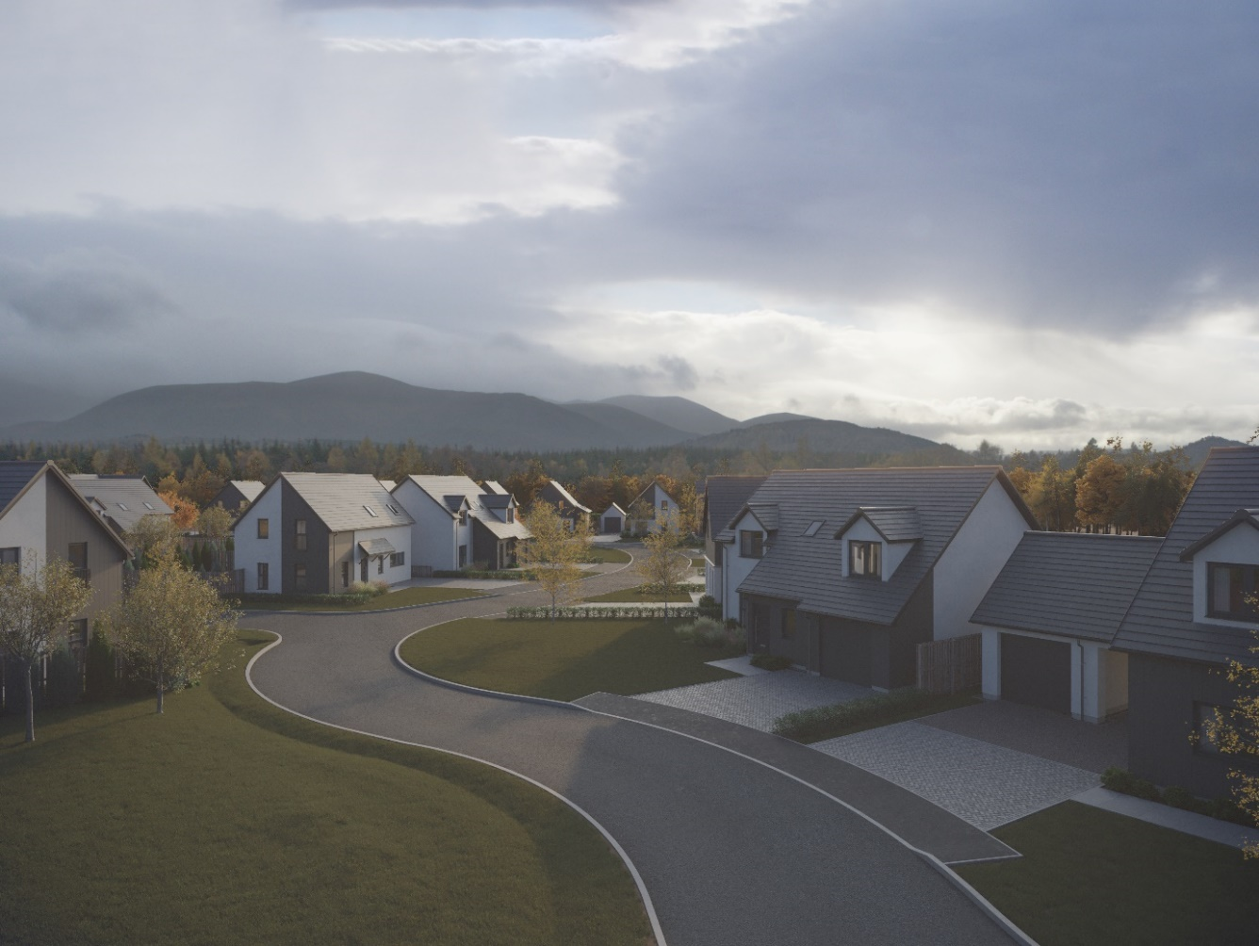

Plots 038-039, 041-044 & 065-071

Walls
External walls will be of timber frame construction with an external leaf of either rendered blockwork or feature panels of anthracite grey, cedar texture, Hardie VL Plank weatherboard cladding, installed in vertical orientation.
Internal walls will be of plasterboard finish mounted on timber studs.

Roof, fasciae & guttering
Roofs will be finished in Marley Edgemere smooth grey interlocking concrete roof tiles. Where applicable, fasciae will be white finish uPVC, with guttering/downpipes in black PVCu.

Exterior colour finishes
The white render finish to blockwork will be specified as a chalk-coloured silicone render system on blockwork above a grey render basecourse.

Floors
The ground floor will be of smooth finished concrete.
Upper floors will be timber joisted with chipboard flooring and plasterboard below.

Windows and doors
All windows will be double glazed uPVC; in anthracite colour (equivalent to RAL 7016) finish externally, white internally; with polished chrome finish handles.
The front entrance doors will be of composite construction; in anthracite colour (equivalent to RAL 7016) finish externally, white colour internally; with Hardex chrome handles and a letter plate (front).
Single leaf rear entrance doors (where applicable) will be double glazed uPVC construction in anthracite colour (equivalent to RAL 7016) finish externally and white colour internally with polished chrome handles.
Outwards opening French doors (double leaf) where fitted, will be double glazed uPVC construction in anthracite colour (equivalent to RAL 7016) finish externally and white colour internally with polished chrome handles.
Garage pedestrian doors (where fitted) will be lined effect uPVC in anthracite colour (equivalent to RAL 7016) finish externally and white colour internally with polished chrome handles.
Internal doors will be ladder moulded semi-solid core timber, in Timeless painted finish, with any glazed doors in a single panel. Handles will be of polished chrome finish with satin grips, all other door ironmongery will be of chrome silver finish.
Internal doors to an integral garage (where provided) will be fire-rated and fitted with a self-closing mechanism.

Internal finishings
Skirting boards and door facings will be square-faced and finished with a rounded edge, with all internal woodwork in Timeless painted finish.
Wardrobes will have hanging rail/s and Timeless painted finish shelving, fitted with silver mirror/frame sliding doors, except in the case of a narrower opening, where a conventional opening timber door will be used.
Other store cupboards will not be shelved.

Internal decoration
Walls and ceilings will be of Timeless painted finish.

Staircase
A timber-formed staircase with solid half-height balustrade partition which will be painted to match the walls and fitted with a painted timber handrail.

Plumbing, central heating and ventilation
A “wet” system using an air source heat pump will be fitted in all properties, feeding thermostatically controlled radiators.
This incorporates a Daikin Altherma system comprising a self-contained floor-standing indoor unit with integrated domestic hot water tank, an external fan unit and a programmable room thermostat.
A de-centralized mechanical extract ventilation (dMEV) system will be fitted, comprised of continuously running extractor fans within the kitchens and “wet” rooms.
An external, self-draining for frost protection, water tap will be fitted.

Electrical installation
Ample white finish power points will be fitted throughout, including TV and telephone points in the Living room and master bedroom. Points in the Kitchen and any open-plan connected Dining Area/Room will be in satin chrome finish.
TV points will be wired to a central distribution point and to the roof space with future installation of an aerial/dish and final connection being the homeowner’s responsibility.
Isolation for kitchen appliances may involve the use of a grid switch in a central location.
Shaver points in all en suites and bathrooms.
All rooms (including Utility cupboards) will be fitted with ceiling light pendants, with chrome finish downlighters fitted in bathrooms and en suites. All lighting fixtures will be installed with low energy type bulbs and positions of electrical points can be seen on plot specific drawings.
Some house designs will also have a mixture of feature lighting within the kitchen.
External lighting will be provided at a front and rear door.
A doorbell will be fitted.
Smoke and heat detectors will be fitted as required by building regulations, with an additional carbon dioxide (CO2) monitor fitted in the principal bedroom in order to record increased levels of carbon dioxide generally produced by exhaled air.

Fibre broadband internet connectivity
Infrastructure will be installed at the development to provide FTTP (Fibre to the Premise) technology, which provides estimated speeds of up to 300Mbps at the entry point to the home.
Final connection and service provision within the home remains the homeowner’s responsibility and ultimate connection speeds will be dependent on the service provided by the chosen communications provider.

Kitchen
A choice of German cabinets and varied laminate work surfaces are offered as standard (subject to stage of completion), with upgraded choices including solid surface worktops also available.
Coordinating laminate up-stands and splashback/s will be fitted above the work surface.
Standard appliances will include built-in electric oven, induction hob, recirculating extractor hood (in some cases this function will be built into the hob), integrated dishwasher and either a tall integrated fridge/freezer or a separate built under fridge and freezer, depending on individual layouts.

Utility rooms & cupboards
Where applicable, utility rooms will be fitted with the same style of cabinets, work surfaces and upstands as chosen for the kitchen.
Designated spaces on kitchen/utility room drawings or in Utility cupboards will be fitted with plumbing (cold water feed and drainage) and electrics for connecting purchaser’s own single or dual self-condensing appliances.
Please refer to separate drawings for specific details.

W.C., bathrooms and en suites
The specification of these rooms has been designed and coordinated by Laings of Inverurie. It will comprise a w.c. and wash hand basin from a range which is of contemporary appearance with appropriate style tap fitments etc. and including vanity units in bathrooms and en suites.
The bath in the bathroom will be fitted with a separate thermostatically controlled flexible shower kit and screen, where there is no separate shower cubicle in the same room.
En-suites (and some bathrooms additionally to the bath) will have a shower tray with up-stand on paneled edges, complete with screen and thermostatically controlled valve.
There will be a choice of Porcelanosa wall tiling to sill height on the basin surrounding wall panel in bathrooms and, where appropriate, en-suites. Where an over bath shower is fitted as standard, tiling to a height of approximately 1.8m on the 3 walls above the bath, otherwise a minimum of one row of tiling around the bath.
Wet wall paneling will be fitted within the shower cubicle of an en-suite.

Gardens
Where possible, gardens will be graded to suit the contours of the development and in some cases, this may involve the creation of slopes instead of retaining walls.
Turf will be laid to front gardens, and shrubbery may be installed in some areas in accordance with the approved landscaping layout. The rear gardens will be rotovated topsoil with a footpath constructed of grey riven paving slabs leading to a rotary clothes drier, which is provided. Small/isolated areas of rear gardens which are not suitable for future turf, such as between paths and fences/garages etc., may be filled with loose gravel.
Individual soakaways will be included within plot garden areas to aid drainage, formed in either a ring or stone soakaway design, please refer to site plan/s for detail/location and the handover pack for ongoing reference, these will need to be retained and maintained.
General drainage will be improved by garden establishment and maintenance.

Parking, driveways & garages
Parking areas and driveways will generally comprise an initial 6000mm of charcoal grey lock block/paviours leading from the public footpath, with the remaining driveway between this and the house being washed gravel held within a cellular paving grid system.
Where a drainage channel with surface grating has been installed, this must be maintained and retained.
Integral garages are within the structural timber frame and have a plasterboard finish internally but remain outside the insulated thermal envelope.
External garages will be of single leaf blockwork construction, with exterior wall and roof finishes to complement the associated house.
The garage floor will be of smooth finished concrete construction.
The vehicular entrance door will be a Garador retractable framed door, with vertically lined anthracite (equivalent to RAL 7016) colour finish and a black handle.
All garages are equipped with power and lighting.

Street lighting
Designed in accordance with Local Authority Guidelines.

Fencing, hedging and walling
Rear gardens will generally be enclosed by a mixture of 1800mm double-sided hit and miss fencing, 1800mm shiplap fencing and 1000mm timber post and mesh/top wire stock fencing; with this height reducing to 900mm on some public and side boundaries between the rear garden and the front of the house and then changing to hedging running to the front boundary.
Where a boundary is shared with other plots on the development and fencing has previously been erected, this will not be replaced and may be subject to natural weathering.
Retaining walls, if and where required, may be made up of slab-on-edge or other construction.
Installation and growth of hedging may be subject to growing season.
Plot specific variations may be checked on site plans.

Efflorescence and ‘lime bloom’
Natural salts within wall materials may appear as a white deposit on external and internal walls as part of the normal drying out process. These are neither harmful nor detrimental to wall finish, durability, or strength in the long term. Exposure to normal weather conditions and naturally acidic rainwater usually removes most of such deposits within the first year of completion.

Factoring
All public open spaces will be maintained by a factor appointed by the developer, please consult the factoring information document for specific details.

Development Management Scheme and/or Deed of Conditions
All owners will be required to comply with the terms of the Deed of Conditions/Development Management Scheme. For further details please ask the Sales Adviser.

Warranties
New build residential properties have the benefit of the 10-year NHBC Buildmark cover.

Applicable Building Warrant
Building (Scotland) Regulations 2004, Technical Handbook 2019 Domestic (effective on all applications from 01st October 2019).
Please read the above in conjunction with site/plot plans and consult your Sales Adviser for further information. Scotia Homes Limited reserves the right to vary the above specifications where necessary but to similar or higher standards. Maintenance, care and cleaning instructions are contained in the HOIP (Home Owner’s Information Pack) issued at handover and these must be followed in accordance with warranty requirements.

