Customer Specification
Dalfaber, Aviemore

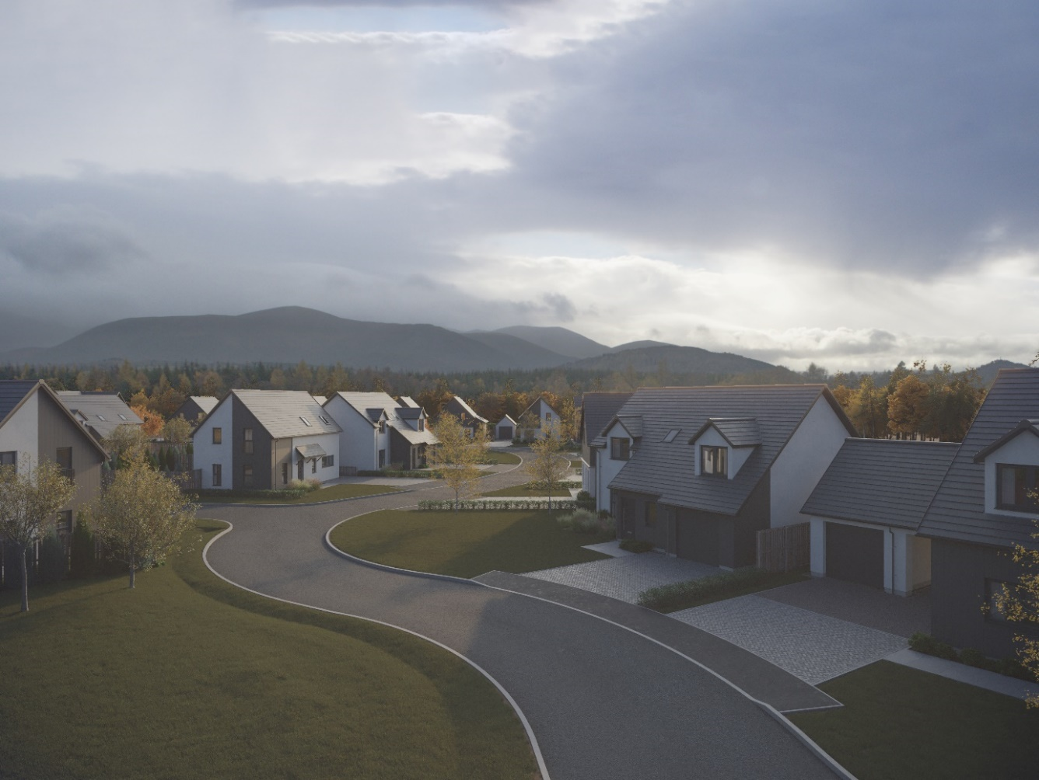
Plots 1-11, 20 & 31-34, 36-37

Walls
External walls will be of Scotframe Val-U-Therm timber frame construction with an external leaf of either rendered blockwork or feature panels of anthracite grey, cedar texture, Hardie VL Plank weatherboard cladding, installed in vertical orientation.
Internal walls will be of plasterboard finish mounted on timber studs.

Roof, fasciae & guttering
Roofs will be finished in Marley Edgemere smooth grey interlocking concrete roof tiles. Where applicable, fasciae will be white finish uPVC, with guttering/downpipes in black PVCu.

Exterior colour finishes
The white render finish to blockwork will be specified as a white thin coat silicone render system on a render carrier board above a grey basecourse.

Floors
The ground floor will be of concrete construction, insulated and with a screed containing the underfloor heating pipework. Upper floors will be timber joisted with chipboard flooring.

Windows and doors
All windows will be double glazed uPVC; in anthracite colour (equivalent to RAL 7016) finish externally, white internally; with satin silver (graphite) finish handles.
Separate roof and combination windows will be of timber construction, with grey aluminium external finish and white painted internal finish.
The front and car port entrance doors will be of composite construction; in anthracite colour (equivalent to RAL 7016) finish externally, white colour internally; with satin silver handles and a letter plate (front).
Rear and garage (pedestrian) entrance doors will be of uPVC construction; in anthracite colour (equivalent to RAL 7016) finish externally, white colour internally; with satin silver handles.
Sliding patio doors will be double glazed uPVC; in anthracite colour (equivalent to RAL 7016) finish externally, white colour internally; with satin silver handles.
Internal doors will be vertically grooved, timber, in Timeless painted finish, with any glazed doors being clear single panel. Handles will be of polished chrome finish with satin grips, all other door ironmongery will be of satin or polished chrome silver finish.
Internal doors to an integral garage will be fire-rated and fitted with a self-closing mechanism.

Internal finishings
Skirting boards and door facings will be square-faced and finished with a rounded edge, with all internal woodwork in Timeless painted finish.
Wardrobes will have hanging rail/s and Timeless painted finish shelving, fitted with silver mirror/frame sliding doors, except in the case of a narrower opening, where a conventional opening timber door will be used.
Other store cupboards will not be shelved.

Internal decoration
Walls and ceilings will be of Timeless painted finish.

Staircase
Staircase balustrades will be formed with timber spindles and newel posts, all in Timeless painted finish, with a varnished timber handrail. A wall-mounted varnished timber handrail will be fitted, where required.

Plumbing, central heating and ventilation
A “wet” system using an air source heat pump will be fitted in all properties. This will feed an underfloor heating system on the ground floor, and thermostatically controlled radiators on upper floors.
This incorporates a Daikin Altherma 3 LT Split system comprising a self-contained floor-standing indoor unit with integrated domestic hot water tank, an external fan unit and a programmable room thermostat.
A de-centralized mechanical extract ventilation (dMEV) system will be fitted, comprised of continuously running extractor fans within the kitchens and “wet” rooms.
A self-draining external tap will be fitted, the effective operation of which must be maintained by following instructions detailed within handover material, including disconnection of all separate hoses etc. during cold weather, otherwise warranty claims resulting from burst pipes will not be upheld.

Electrical installation
Ample power points will be fitted throughout, with a telephone/digital TV/satellite multi-point in the living room and master bedroom. TV points will be wired to a central distribution point and to the roof space with future installation of an aerial/dish and final connection being the homeowner’s responsibility. Certain power points in the Kitchen area and bedrooms will be equipped with USB/A outlets. Electrical points on the ground floor will be (where visible and available) in satin chrome finish, with those on the first floor white (except for plots 031-032, 008-021, 023-030, 035, 038-039, 041-70 & 076 which will also be satin chrome finish on the first floor).
Isolation for kitchen appliances may involve the use of a grid switch in a central location.
A shaver point will be fitted in bathrooms and en suites.
Kitchens, bathrooms and en suites will be fitted with satin chrome finish LED downlighters. All other rooms (including Utility cupboards) will be fitted with ceiling light pendants including LED bulbs.
Positions and types of electrical points can be seen on plot specific drawings.
Some house designs will also have a mix of feature lighting within the kitchen.
External lighting positions can be seen on plot specific drawings. Public elevations will be fitted with a stainless steel up and downlighter with PIR sensor on public elevations, with a bulkhead style light fitting on private elevations.
A doorbell will be fitted.

Fibre broadband internet connectivity
Infrastructure will be installed at the development to provide FTTP (Fibre to the Premise) technology, which provides estimated speeds of up to 300Mbps at the entry point to the home.
Final connection and service provision within the home remains the homeowner’s responsibility and ultimate connection speeds will be dependent on the service provided by the chosen communications provider.

Kitchen
A choice of UK manufacturer fitted furniture, handles and varied laminate work surfaces are offered as standard (subject to stage of completion), with upgraded choices including solid surface worktops also available.
A coordinating laminate up-stand will be fitted above the work surface with a glass splash-back behind the hob.
Standard appliances will include; Neff built-in stainless steel electric oven and separate combination microwave oven, electric induction hob, recirculating extractor hood (function built-in to the hob in some cases), Concealed integrated appliances will include a Hotpoint tall integrated fridge/freezer and dishwasher, with some properties including separate tall integrated fridge and freezer. Please refer to separate Kitchen and house drawings for specific details.

Utility rooms & cupboards
Where applicable, utility rooms will be fitted with the same style of furniture and work surfaces/upstands as chosen for the kitchen.
Designated spaces on kitchen drawings or in Utility cupboards will be fitted with plumbing (cold water feed and drainage) and electrics for connecting purchaser’s own single or dual self-condensing appliances. Please refer to separate drawings for specific details.

W.C., bathrooms and en suites
All will comprise sanitary ware from a Porcelanosa range which is of contemporary appearance with appropriate style tap fitments etc. and a sink vanity unit in bathrooms and en suites.
Fitted mirrors are to be located above basins in bathrooms and en suites, where possible.
Porcelanosa wall tiling in larger formats can be chosen from a range of pre-selections, including some feature walls. These pre-selections also include standard Porcelanosa floor tiling.
A pearl shine silver finish heated towel rail will be fitted to bathrooms and en suites in lieu of a radiator (except in some situations where available height requires a smaller towel rail and separate radiator). This rail can either be heated from the central heating system or switched to electric operation when the house does not require central heating.
Please refer to separate Bathroom and house drawings for specific details.

Gardens
Where possible, gardens will be graded to suit the contours of the development and in some cases, this may involve the creation of slopes instead of retaining walls.
Turf will be laid to front gardens and shrubbery may be installed in some areas in accordance with the approved landscaping layout. The rear gardens will be rotovated topsoil with a footpath constructed of grey riven paving slabs leading to a rotary clothes drier, which is provided. Small/isolated areas of rear gardens which are not suitable for future turf, such as between paths and fences/garages etc., may be filled with loose gravel.
Individual soakaways will be included within plot garden areas to aid drainage, formed in either a ring or stone soakaway design, please refer to site plan/s for detail/location and the handover pack for ongoing reference, these will need to be retained and maintained.
General drainage will be improved by garden establishment and maintenance.

Parking, driveways & garages
Parking areas and driveways will generally comprise an initial 6000mm of charcoal grey lock block/paviours leading from the public footpath, with the remaining driveway between this and the house being washed gravel held within a cellular paving grid system.
Where a drainage channel with surface grating has been installed, this must be maintained and retained.
Integral garages are within the structural timber frame and have a plasterboard finish internally, but outside the insulated thermal envelope.
External garages will be of single leaf blockwork construction, internally and externally, with exterior wall and roof finishes to complement the associated house.
The garage floor will be of smooth finished concrete construction.
The vehicular entrance door will be a Garador retractable framed door, with vertically lined anthracite (equivalent to RAL 7016) colour finish and a black handle.
All garages are equipped with power and lighting.

Street lighting
Designed in accordance with Local Authority Guidelines.

Fencing, hedging and walling
Rear gardens will generally be enclosed by a mixture of 1800mm single-sided hit and miss fencing, 1800mm shiplap fencing and 1000mm timber post and mesh/top wire stock fencing; with this height reducing to 900mm on some public and side boundaries between the rear garden and the front of the house, and then changing to hedging running to the front boundary.
Where a boundary is shared with other plots on the development and fencing has previously been erected, this will not be replaced and may be subject to natural weathering.
Retaining walls, if and where required, may be made up of slab-on-edge or other construction.
Installation and growth of hedging may be subject to growing season.
Plot specific variations may be checked on site plans.

Efflorescence and ‘lime bloom’
Natural salts within wall materials may appear as a white deposit on external and internal walls as part of the normal drying out process. These are neither harmful nor detrimental to wall finish, durability, or strength in the long term. Exposure to normal weather conditions and naturally acidic rainwater usually removes the majority of such deposits within the first year of completion.

Factoring
All public open spaces will be maintained by a factor appointed by the developer, please consult the factoring information document for specific details.

Development Management Scheme and/or Deed of Conditions
All owners will be required to comply with the terms of the Deed of Conditions/Development Management Scheme. For further details please ask the Sales Adviser.

Warranties
New build residential properties have the benefit of the 10-year NHBC Buildmark cover.

Applicable Building Warrant
Building (Scotland) Regulations 2004, Technical Handbook 2019 Domestic (effective on all applications from 01st October 2019).
Please read the above in conjunction with site/plot plans and consult your Sales Adviser for further information. Scotia Homes Limited reserves the right to vary the above specifications where necessary but to similar or higher standards. Maintenance, care and cleaning instructions are contained in the HOIP (Home Owner’s Information Pack) issued at handover and these must be followed in accordance with warranty requirements.

