Customer Specification
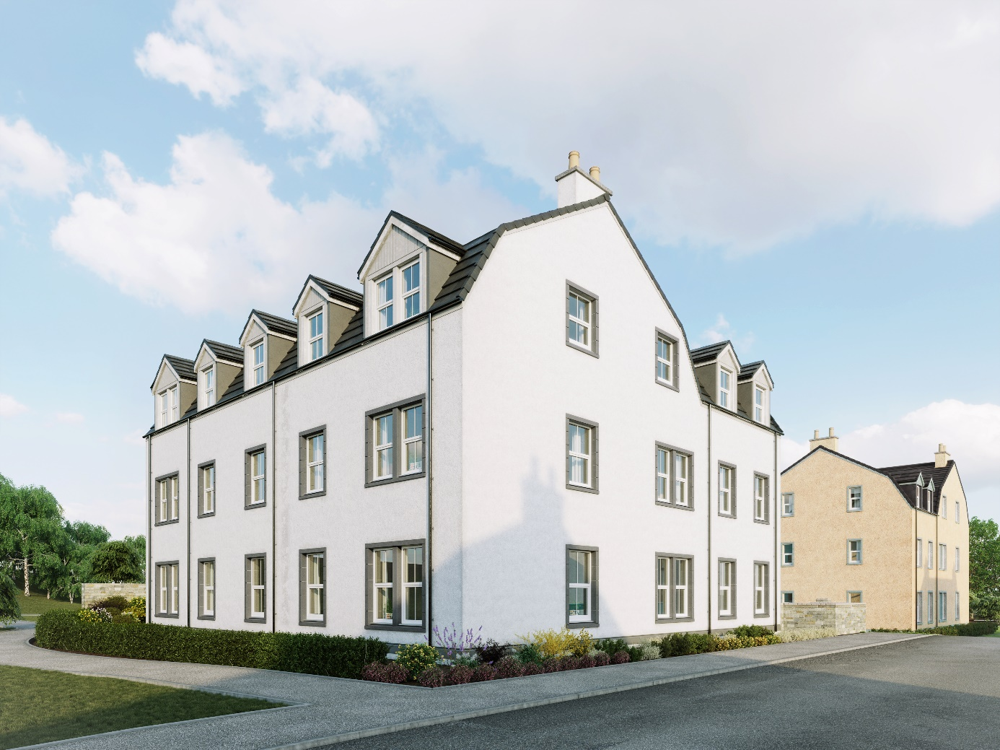

Charleston, Cove

Flats

Plots 701-706 & 726-731

Walls
External walls will be of timber frame construction with external leaf of render block-work and architectural detailing. Timber studs with insulation and plasterboard finish internally.

Roof, fasciae & guttering
All roofs to be finished in either flat concrete slate effect interlocking roof tiles or concrete tiles. Where applicable, fasciae are to be white uPVC and all gutters/downpipes are uPVC.

Exterior colour finishes
External finish of dry dash render finish and/or stone effect features.
Please refer to the exterior colour finishes palette for individual details to the exterior.

Floors
The ground floor will be of smooth finished concrete. Upper timber separating floors finished in chipboard.

Windows and doors
All windows are double glazed high performance uPVC to resemble a traditional style.
The front and rear entrance doors are to be traditional style painted with chrome finish ironmongery.
Front and rear entrance doors will be black.
Internal flat entrance doors will be black and will have a number affixed to the outside, with appropriate numbers denoted on external door entry systems.
All internal doors to be painted panel doors with chrome finish ironmongery.

Internal finishings
Painted medium density fibreboard (MDF) moulded and beaded facings and skirting boards.
Hanging rail and shelving in all wardrobes and dressing areas.

Internal decoration
Two coats of Timeless emulsion to walls of all rooms except bathrooms and en suites which will be white.
Doors, facings and skirting boards will also be Timeless except bathrooms and en suites which will be white.
Two coats of white emulsion will be given to all ceilings.

Central Heating
A gas “wet” system with thermostatically controlled radiators will be fitted in all properties.
This incorporates an Alpha FlowSmart system comprising an InTec boiler, a GasSaver flue gas heat recovery unit and in some cases a thermal store, with a programmable room thermostat.

Ventilation System
A de-centralized mechanical extract ventilation (dMEV) system will be fitted, comprised of continuously running extractor fans within the kitchen and “wet” rooms.

Electrical installation
Ample sockets fitted throughout, including a telephone/digital TV/satellite multi-point in the living/drawing room.
A fibre optic digital aerial and satellite signal from a communal dish/aerial will be provided to each plot.
Shaver points in all en suites and bathrooms.
Central ceiling light pendants to all rooms. Some house designs will also have a mix of feature lighting within the kitchen.
All lighting fixtures will be installed with low energy type bulbs and an electrical energy monitor will be fitted.

Fibre broadband internet connectivity
Infrastructure will be installed at the development to provide FTTP (Fibre to the Premise) technology, which provides estimated speeds of up to 300Mbps at the entry point to the home.
Final connection and service provision within the home remains the homeowner’s responsibility and ultimate connection speeds will be dependent on the service provided by the chosen communications provider.

Kitchen
A choice of cabinets and varied work surfaces are offered, and will include built-in stainless steel electric single oven, electric hob, recirculation extractor hood and either integrated built under fridge and freezer or built under fridge with ice box, depending on individual layouts.
A coordinating laminate up-stand will be fitted above the work surface with a glass splash-back behind the hob.

Utility cupboards (where applicable)
Designated spaces in Utility cupboards will be fitted with plumbing (cold water feed and drainage) and electrics for connecting purchaser’s own single or dual self-condensing appliances.

Bathrooms & en suites
All comprise w.c. and wash hand basin from a range which is of contemporary appearance with appropriate style tap fitments etc.
Where there is no en suite, the bath in the bathroom will be fitted with a separate thermostatically controlled flexible shower kit and screen.
En suites will have a shower tray with up-stand on panelled edges, complete with screen and thermostatically controlled valve.
Fitted mirrors are to be located above basins in bathrooms and en suites, where possible.
Choice of wall tiling to sill height on the basin surrounding wall panel in bathrooms and, where appropriate, en suites. Where an over bath shower is fitted as standard, tiling to a height of approximately 1800mm on the 3 walls above the bath, otherwise one row of tiling around the bath in bathrooms.
Aqua panelling will be fitted within the shower cubicle of an en suite.

Common Stairwells
An interior designer will coordinate the décor and flooring finish of entrance halls, which will also be fitted with sensor lighting. A security entrance door system will be installed with an audio link to each flat.

Parking
Parking spaces are shared, with one space being factor allocated and numbered to each apartment. The factor allocated space forms part of the shared parking and will not fall within the title/ownership of the apartment.
Additional visitor spaces may be available, with some being designated/designed as accessible space, positions and numbers of all of the above can be viewed on site plans.

Street lighting
Designed in accordance with Local Authority Guidelines.

Efflorescence and ‘lime bloom’
Natural salts within wall materials may appear as a white deposit on external and internal walls as part of the normal drying out process. These are neither harmful nor detrimental to wall finish, durability or strength in the long term. Exposure to normal weather conditions and naturally acidic rain water usually removes the majority of such deposits within the first year of completion.

Factoring
All public open spaces will be maintained by a factor appointed by the developer.

Development Management Scheme and/or Deed of Conditions
All owners will be required to comply with the terms of the Deed of Conditions/Development Management Scheme, the purposes of which include ensuring the continuing architectural harmony of the development. For further details please ask the Sales Adviser.

Warranties
New build residential properties have the benefit of the 10-year NHBC Buildmark cover.

Applicable Building Warrant
Building (Scotland) Regulations 2004; Domestic Handbook 2013
Building (Scotland) Regulations 2004; Domestic Handbook 2015 (plots 620-643, subject to approval)
Please consult your Sales Adviser for further information. Scotia Homes Limited reserves the right to vary the above specifications where necessary but to similar or higher standards.

