Customer Specification
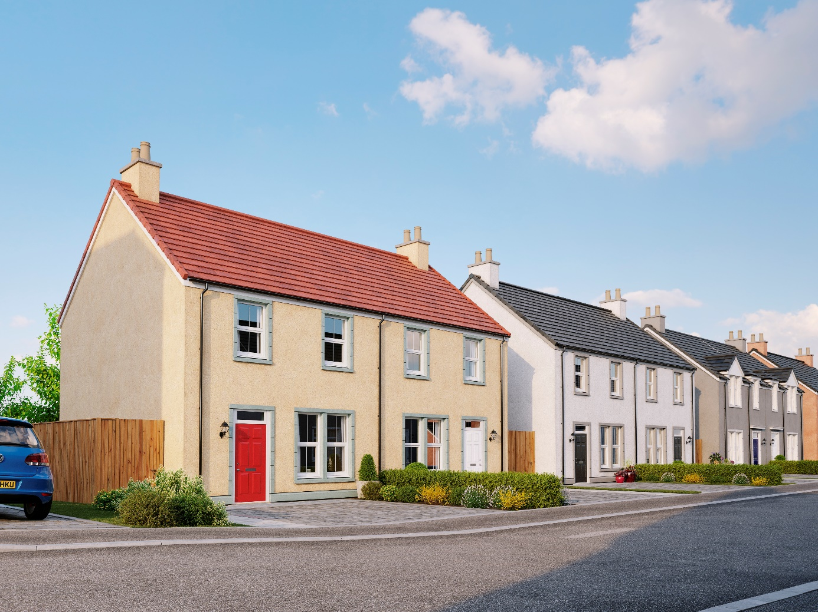
Charleston, Cove

Houses & self-contained apartments

Plots 516-528, 601-619, 707-725 & 732-745

Walls
External walls will be of timber frame construction with external leaf of render block-work and architectural detailing. Timber studs with insulation and plasterboard finish internally.

Roof, fasciae & guttering
All roofs to be finished in either flat concrete slate effect interlocking roof tiles or concrete tiles. Fasciae are to be white uPVC and all gutters/downpipes are uPVC.

Exterior colour finishes
External finish of either wet or dry dash render finish and/or architectural details.
Please refer to the exterior colour finishes palette for individual details to the exterior.

Floors
The ground floor will be of smooth finished concrete. Upper floors of engineered joists finished with chipboard flooring, with additional insulation for fire and sound between self-contained apartments.

Windows and doors
All windows are double glazed high performance uPVC to resemble a traditional style.
The front and rear entrance doors are to be traditional style painted with chrome finish ironmongery. Please see the exterior colour finishes palette for front door colour choices, the rear door colour will be white.
All internal doors to be painted panel doors with chrome finish ironmongery, some wardrobes will be fitted with silver mirrored, brushed silver framed sliding doors.

Internal finishings
Painted medium density fibreboard (MDF) moulded and beaded facings and skirting boards.
Hanging rail and shelving in all wardrobes and dressing areas.

Internal decoration
Two coats of Timeless emulsion to walls of all rooms except bathrooms, en suites and cloakrooms which will be white.
Doors, facings and skirting boards will also be Timeless except bathrooms, en suites and cloakrooms which will be white.
Two coats of white emulsion will be given to all ceilings.

Staircase
Timeless painted timber balustrading with varnished hardwood handrail.

Central Heating
A gas “wet” system with thermostatically controlled radiators will be fitted in all properties.
This incorporates an Alpha FlowSmart system comprising an InTec boiler, a GasSaver flue gas heat recovery unit and in some cases a thermal store, with a programmable room thermostat.

Ventilation System
A de-centralized mechanical extract ventilation (dMEV) system will be fitted, comprised of continuously running extractor fans within the kitchen, utility and “wet” rooms.

Electrical installation
Ample sockets fitted throughout, including a telephone/digital TV/satellite multi-point in the living/drawing room.
A fibre optic digital aerial and satellite signal from a communal dish/aerial will be provided to each plot.
Shaver points in all en-suites and bathrooms.
Where an under-stairs cupboard has a full height door, a light will be fitted.
Central ceiling light pendants to all rooms. Some house designs will also have a mix of feature lighting within the kitchen. All lighting fixtures will be installed with low energy type bulbs and an electrical energy monitor will be fitted.
A doorbell will be fitted at the front door.

Fibre broadband internet connectivity (excluding plots 516-528)
Infrastructure will be installed at the development to provide FTTP (Fibre to the Premise) technology, which provides estimated speeds of up to 300Mbps at the entry point to the home.
Final connection and service provision within the home remains the homeowner’s responsibility and ultimate connection speeds will be dependent on the service provided by the chosen communications provider.

Kitchen
A choice of cabinets and varied work surfaces are offered, and will include built-in stainless steel electric single oven, gas or electric (self-contained apartments) hob, recirculation extractor hood and integrated fridge freezer (will be either an upright or separate units depending on individual layouts).
A coordinating laminate up-stand will be fitted above the work surface with a glass splash-back behind the hob.

Utility rooms & cupboards
Where applicable, utility rooms will be fitted with the same style of cabinets, work surfaces and up-stands as chosen for the kitchen.
Designated spaces on kitchen drawings or Utility cupboards will be fitted with plumbing (cold water feed and drainage) and electrics for connecting purchaser’s own single or dual self-condensing appliances.

Cloakrooms, Bathrooms & W.C.
All comprise w.c. and wash hand basin from a range which is of contemporary appearance with appropriate style tap fitments etc.
Where there is no en suite, the bath in the bathroom will be fitted with a separate thermostatically controlled flexible shower kit and screen.
En suites will have a shower tray with up-stand on panelled edges, complete with screen and thermostatically controlled valve.
Fitted mirrors are to be located above basins in bathrooms and en suites, where possible.
Choice of wall tiling to sill height on the basin surrounding wall panel in bathrooms and, where appropriate, en suites. Where an over bath shower is fitted as standard, tiling to a height of approximately 1800mm on the 3 walls above the bath, otherwise one row of tiling around the bath in bathrooms.
Aqua panelling will be fitted within the shower cubicle of an en suite.

Gardens
Where possible, gardens will be graded to suit the contours of the development and in some cases this may involve the creation of slopes instead of retaining walls.
Landscaping with shrubs and/or turf to front gardens.
The rear gardens are to be rotovated topsoil with a footpath constructed of paving slabs leading to a rotary clothes drier, which is provided.
Gravel topped French drains may be included to aid drainage, these will need to be retained and maintained.
General drainage will be improved by garden establishment and maintenance.

Parking, driveways & garages
Driveways and parking areas are to be lock block and/or gravel.
Garages will be rendered block-work, except where the exterior colour finishes schedule details otherwise.
Garage front doors will be the same colour as front doors.
All garages are equipped with power and lighting.
Please refer to the exterior colour finishes palette for individual details to the exterior.

Street lighting
Designed in accordance with Local Authority Guidelines.

Fencing and walling
Boundary enclosures will be a mix of timber fencing and walling.
Where a boundary is shared with other plots on the development and fencing has previously been erected, this will not be replaced and may be subject to natural weathering.

Efflorescence and ‘lime bloom’
Natural salts within wall materials may appear as a white deposit on external and internal walls as part of the normal drying out process. These are neither harmful nor detrimental to wall finish, durability or strength in the long term. Exposure to normal weather conditions and naturally acidic rain water usually removes the majority of such deposits within the first year of completion.

Factoring
All public open spaces will be maintained by a factor appointed by the developer.

Development Management Scheme and/or Deed of Conditions
All owners will be required to comply with the terms of the Deed of Conditions/Development Management Scheme, the purposes of which include ensuring the continuing architectural harmony of the development. For further details please ask the Sales Adviser.

Warranties
New build residential properties have the benefit of the 10-year NHBC Buildmark cover.

Applicable Building Warrant
Building (Scotland) Regulations 2004; Domestic Handbook 2013
Please consult your Sales Adviser for further information. Scotia Homes Limited reserves the right to vary the above specifications where necessary but to similar or higher standards.

