Customer Specification
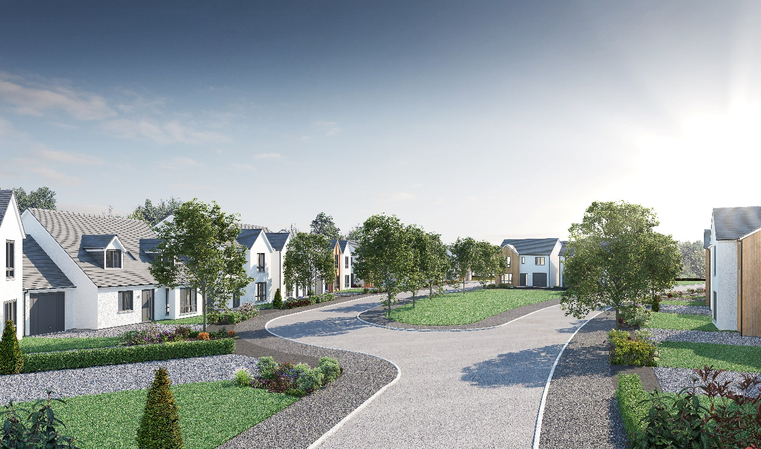
Hamilton Gardens, Elgin
Plots 55-59, 87, 201-223 & 260-305

Walls
External walls will be of timber frame construction with external leaf of render block-work, or feature timber cladding may be used in some situations.
Timber studs with insulation and plasterboard finish internally.

Roof, fasciae & guttering
All roofs to be finished in concrete interlocking roof tiles, except for the ground floor front addition of the Brodie house type, which will be flat and finished with a single ply roofing membrane.
Fasciae are to be white uPVC and all gutters/downpipes are black uPVC.

Exterior colour finishes
Please refer to the exterior colour finishes palette for individual details to the exterior.

Floors
The ground floor will be of smooth finished concrete. First floor of timber joists finished with moisture resistant chipboard flooring above and plasterboard ceiling below.

Windows and doors
All windows are double glazed high performance grey uPVC externally, with white internal finishes.
The front entrance doors are to be of vertically lined and grained grey external colour finish (white internal finish) GRP construction, with polished chrome finish ironmongery, some of which will have a glass panel.
A door number will be fitted.
French style doors are to be double glazed high performance grey uPVC, with white internal finishes.
Internal doors to be ladder moulded painted finish doors with polished chrome finish ironmongery.

Internal finishings
Painted medium density fibreboard (MDF) square profile facings and skirting boards.
Hanging rail and shelving in wardrobes and dressing areas.

Internal decoration
Two coats of timeless emulsion to walls of all rooms, except within cloakrooms, bathrooms and en suites which will be white.
Two coats of white emulsion to all ceilings.
Timeless painted finish to all internal woodwork, except within cloakrooms, bathrooms and en suites which will be white (plots completed prior to plot 267 will have all internal woodwork painted in white).

Staircase
Painted timber balustrading and hardwood handrail.

Central Heating
A gas “wet” system with thermostatically controlled radiators will be fitted in all properties.
This incorporates an Alpha FlowSmart system comprising an InTec boiler, a GasSaver flue gas heat recovery unit and in some cases a thermal store, with a programmable room thermostat.

Ventilation System
A de-centralized mechanical extract ventilation (dMEV) system will be fitted, comprised of continuously running extractor fans within the kitchen, utility and “wet” rooms.

Electrical installation
Ample white finish power points will be fitted sockets throughout, including TV and telephone points in the Living room.
Isolation for kitchen appliances may involve the use of a grid switch in a central location.
Shaver points in all en suites and bathrooms.
All rooms (including Utility cupboards) will be fitted with ceiling light pendants, with a single additional downlighter fitted above shower cubicles. All lighting fixtures will be installed with low energy type bulbs and positions of electrical points can be seen on plot specific drawings.
Some house designs will also have a mix of feature lighting within the kitchen.
External lighting will be provided at a front and rear door.
A doorbell will be fitted.

Kitchen
A choice of German cabinets and varied work surfaces are offered as standard, and will include built-in stainless steel electric oven, gas hob, recirculating extractor hood and either a tall integrated fridge/freezer or separate built under fridge and freezer, depending on individual layouts.
A coordinating laminate up-stand will be fitted above the work surface with a glass splash-back behind the hob.

Utility rooms & cupboards
Where applicable, utility rooms will be fitted with the same style of cabinets, work surfaces and up-stands as chosen for the kitchen.
Designated spaces on kitchen drawings or in Utility cupboards will be fitted with plumbing (cold water feed and drainage) and electrics for connecting purchaser’s own single or dual self-condensing appliances.

W.C., bathrooms and en suites
All will comprise a w.c. and wash hand basin from a range which is of contemporary appearance with appropriate style tap fitments etc.
Where there is no en-suite, the bath in the bathroom will be fitted with a separate thermostatically controlled flexible shower kit and screen.
En-suites will have a shower tray with up-stand on panelled edges, complete with screen and thermostatically controlled valve.
Fitted mirrors are to be located above basins in bathrooms and en-suites, where possible.
Choice of wall tiling to sill height on the basin surrounding wall panel in bathrooms and, where appropriate, en-suites. Where an over bath shower is fitted as standard, tiling to a height of approximately 1.8m on the 3 walls above the bath, otherwise a minimum of one row of tiling around the bath in bathrooms.
Aqua panelling will be fitted within the shower cubicle of an en-suite.

Gardens
Where possible, gardens will be graded to suit the contours of the development and in some cases this may involve the creation of slopes instead of retaining walls.
Turf will be laid to front gardens.
The rear gardens will be rotovated topsoil with a footpath constructed of grey riven paving slabs leading to a rotary clothes drier, which is provided.
Gravel topped French drains may be included to aid drainage, these will need to be retained and maintained. General drainage will be improved by garden establishment and maintenance.

Parking, driveways & garages
Parking areas and driveways will generally comprise an initial 2000mm of lock block leading from the public footpath, with the remaining driveway between this and the house being washed gravel.
Garages will have an “up and over” retractable, vertically lined entrance door, with grey painted finish. Garages will be equipped with power and lighting.

Street lighting
Designed in accordance with Local Authority Guidelines.

Fencing, hedging and walling
Plot specific details may be checked on site plans.
Where a boundary is shared with other plots on the development and fencing has previously been erected, this will not be replaced and may be subject to natural weathering.

Efflorescence and ‘lime bloom’
Natural salts within wall materials may appear as a white deposit on external and internal walls as part of the normal drying out process. These are neither harmful nor detrimental to wall finish, durability or strength in the long term. Exposure to normal weather conditions and naturally acidic rain water usually removes the majority of such deposits within the first year of completion.

Factoring
All public open spaces will be maintained by a factor appointed by the developer.

Development Management Scheme and/or Deed of Conditions
All owners will be required to comply with the terms of the Deed of Conditions/Development Management Scheme. For further details please ask the Sales Adviser.

Warranties
New build residential properties have the benefit of the 10-year NHBC Buildmark cover.

Applicable Building Warrant
Building (Scotland) Regulations 2004; Domestic Handbook 2013
Please consult your Sales Adviser for further information. Scotia Homes Limited reserves the right to vary the above specifications where necessary but to similar or higher standards.

